

|  |
| --- |
| JAVA PROJECT DOCUMENTATION |
| **MILK TEA SHOP** |
| **MILK TEA SHOP MANAGEMENT SYSTEM** |

|  |
| --- |
| Can Tho city, 10-15-2019 |

# PROJECT TEAM INTRODUCTION

* Project manager
  + Teacher. Luong The Anh
  + Email: [ltanh@ctu.edu.vn](mailto:ltanh@ctu.edu.vn)
* Team Leader/Analyst/Designer/Tester
  + Student. Dao Minh Trung Thuan
  + Student ID: Student1153187
  + Email: [DmtthuanA18088@cusc.ctu.edu.vn](mailto:DmtthuanA18088@cusc.ctu.edu.vn)
* Team Member/Developer/Tester
  + Student. Ha Thi Hong Tham
  + Student ID: Student1138919
  + Email: [HththamA18124@cusc.ctu.edu.vn](mailto:HththamA18124@cusc.ctu.edu.vn)
* Team Member/Developer/Tester
  + Student. Tan Tan Lap
  + Student ID: Student1146966
  + Email: [TtlapA18081@cusc.ctu.edu.vn](mailto:TtlapA18081@cusc.ctu.edu.vn)

|  |  |  |
| --- | --- | --- |
| **Design Plan:** | **Document name: Problem Definition** | **SWD/Form No.2A** |
| **Effective Date:15/10/2019** | **Version: 1** | **Page No:** |

# PROBLEM DEFINITION OF MILK TEA SHOP

Milk Tea Shop is a milk tea shop specializing in selling milk tea and fast food. The main customers that it serves are students. When customers come to the shop, they order food and choose their own seat that they like then pay for bill at cashier.

But recently, the number of customers is increasing. The shop manager feels difficult to record and manage not only the invoice but also revenue of the shop. In addition, employees cannot write lots of order bill every day. So, they want to have a system can help them to manage their shop that customers can order bill simpler and employees don’t work too much.

The system will provide functions:

* Customers can order food, choose their table that they like then pay at cashier
* Customers can register and log into system or enter discount code to receive the offer from shop
* Employees and manager must log in to use system.
* Employees can manage order bills in food tables, status of food tables, and food
* Manager can manage bills, employees, accounts and income of shop.
* Manager’s actions include view, insert, update, delete. But employee cannot delete or update anything. The order bill can be canceled when in the order process but not delete when customer has paid.

Beside that:

* The system must run smoothly, without errors from the system side.
* Fast execution speed, serving the crowded customer flow.

|  |  |  |
| --- | --- | --- |
| **Date:** | **Prepare by (Student)** | **Approve by (Teacher)** |
| **15/10/2019** | **Ha Thi Hong Tham**  **Dao Minh Trung Thuan** | **Luong The Anh** |

|  |  |  |
| --- | --- | --- |
| **Design Plan:** | **Document name: CRS** | **SWD/Form No.2A** |
| **Effective Date: 15/10/2019** | **Version: 1** | **Page No:** |

# CUSTOMER REQUIREMENT SPECIFICATION

## List of input to the system

**Account: User account in the system**

* Id: id account.
* Account: account name.
* Password: password.
* Roll: roll of account (1: customer, 2: employee, 3: manager).
* Name: name of account owner.
* Gender: gender of account owner.
* Birthday: the date of birth of account owner.
* Address: address of account owner.
* Phone: phone number of account owner.
* Email: email of account owner.
* Status: status of account (1: enable, 0: disable).

**Table Food: Information of table**

* Id: id table.
* X: coordinates X of table.
* Y: coordinates Y of table.
* Status: status of account (2: busy, 1: enable, 0: disable).

**Category: Category of food**

* Id: id category.
* Name: type name.
* Status: status of account (1: enable, 0: disable).

**Food: Information of food**

* Id: id food.
* Name: name of food.
* Id Category: classify on food (foreign key of Category).
* Price: price of food

|  |  |  |
| --- | --- | --- |
| **Date:** | **Prepare by (Student)** | **Approve by (Teacher)** |
| **15/10/2019** | **Ha Thi Hong Tham**  **Tan Tan Lap** | **Luong The Anh** |

|  |  |  |
| --- | --- | --- |
| **Design Plan:** | **Document name: CRS** | **SWD/Form No.2A** |
| **Effective Date: 15/10/2019** | **Version: 1** | **Page No:** |

* Status: status of account (1: enable, 0: disable).

**Discount: Information of discount**

* Id: id discount.
* Name: code value.
* Sale: discount values (example: 15%).
* Status: status of account (2: giving out, 1: enable, 0: disable).

**Bill: Information of bill**

* Id: id of bill.
* Id Table Food: id number of table (foreign key of Table Food).
* Id Customer: id number of Customer (foreign key of Account).
* Id Employee: id number of Employee (foreign key of Account).
* Id Discount: id number of Discount (foreign key of Discount).
* Sale: total sale of bill
* Check In: the time that customer paid bill.
* Check Out: the time that customer left the shop.

**Bill Detail: Information of bill detail**

* Id: id bill detail.
* Id Bill: id number of table Bill (Foreign Key of bill).
* Id Food: id number of table Food.
* Name Food: name ordered food.
* Id Category: id number category of food.
* Name Category: name category of ordered food.
* Quantity: quantity of food.
* Price: price of ordered food

## List of output expected from the system

**For Customer**

* Display food list.
* Display food category.

|  |  |  |
| --- | --- | --- |
| **Date:** | **Prepare by (Student)** | **Approve by (Teacher)** |
| **15/10/2019** | **Ha Thi Hong Tham**  **Tan Tan Lap** | **Luong The Anh** |

* Display bill details and total price when ordering.

|  |  |  |
| --- | --- | --- |
| **Design Plan:** | **Document name: CRS** | **SWD/Form No.2A** |
| **Effective Date: 15/10/2019** | **Version: 1** | **Page No:** |

* Display information of account when logged in.
* Display food table list when paid bill.

**For Employee**

* Display food table list.
* Display bill list of each table in that day
* Display bill details of each bill.
* Display bill details that customers are ordering.
* Display information of account when logged in.
* Display food list.
* Display food category.

**For Manager**

* Display table list.
* Display employee list and account of each employee.
* Display customer list and account of each customer.
* Display discount code list.
* Display bill list and bill details of each bill.
* Display food list.
* Display food category.
* Display income.
* Export income report.

## Overview of processes involved in the system

**For Customer**

* Watch category food and food list, choose food.
* Watch bill details that ordered.
* Customers can cancel order if they have not paid.
* Pay bill and watch table list, choose table.
* Login account to discount bill.
* Enter discount code.

|  |  |  |
| --- | --- | --- |
| **Date:** | **Prepare by (Student)** | **Approve by (Teacher)** |
| **15/10/2019** | **Ha Thi Hong Tham**  **Tan Tan Lap** | **Luong The Anh** |

|  |  |  |
| --- | --- | --- |
| **Design Plan:** | **Document name: CRS** | **SWD/Form No.2A** |
| **Effective Date: 15/10/2019** | **Version: 1** | **Page No:** |

* Watch information of account.
* Register account.

**For Employees**

* Watch category food and food list.
* Watch bill details that customer is ordering.Watch table list.
* Watch bill list and bill details of each table in that day.
* Watch information of account.
* Check out the bill of table.

**For Manager**

* Manage category food: watch, insert, update, delete categories food.
* Manage food: watch, insert, update, delete food.
* Manage bill: watch bills and bill details.
* Manage employee: watch, insert, update, delete information and account of employees.
* Manage customer: watch, insert, update, delete information and account of customers.
* Manage discount code: watch, insert, update, delete discount code.
* Manage income of shop, export report.

## Hardware and software required for implementing the project

### Hardware

* CPU : 1.8 GHz or faster processor. Quad-core or better recommended.
* Ram : 2 GB of RAM. 8 GB of RAM recommended.
* Hard disk space : Minimum of 800MB up to 256 GB or more of available space depending on increasing database.
* Hard disk speed : To improve performance, install Operating System and Project run on SSD drive.
* Display screen size : Supports a minimum display 1600 x 900.

|  |  |  |
| --- | --- | --- |
| **Date:** | **Prepare by (Student)** | **Approve by (Teacher)** |
| **15/10/2019** | **Ha Thi Hong Tham**  **Tan Tan Lap** | **Luong The Anh** |

|  |  |  |
| --- | --- | --- |
| **Design Plan:** | **Document name: CRS** | **SWD/Form No.2A** |
| **Effective Date: 15/10/2019** | **Version: 1** | **Page No:** |

### Supported locale:

* Language: English
* Currency unit: Dollars ($)

### Environment

* Operating system :
* Project will install and run on the following operating systems (Windows 10 64 bit recommended)
* Environment
* Java 11.0.4
* JavaFX 2.0
* Database server
* Microsoft SQL Server (SQL Server 2016 recommended)
* Microsoft SQL Server Management Studio 18 for managing database.

|  |  |  |
| --- | --- | --- |
| **Date:** | **Prepare by (Student)** | **Approve by (Teacher)** |
| **15/10/2019** | **Ha Thi Hong Tham**  **Tan Tan Lap** | **Luong The Anh** |

|  |  |  |
| --- | --- | --- |
| **Design Plan:** | **Document name: Acceptance Criteria** | **SWD/Form No.2B** |
| **Effective Date: 15/10/2019** | **Version: 1** | **Page No:** |

# CUSTOMER ACCEPTANCE CRITERIA

**For Customer**

* Customers can watch food and price in food list.
* Customers can order food and pay bill.
* Customers can cancel ordering when they had not pay.
* Customers can choose table food after paying bill.
* Customers can login or enter discount code in order to discount bill.
* Customers can register, account will create automatically with information that customer registered.
* Customers can watch information of their account.

**For Employee**

* Employees must login to use system.
* Employees can watch bill and table that customer is ordering.
* Employees can watch list of food.
* Employees can watch status of tables and bills in that day of each table.
* Employees can watch information of their account.

**For Manager**

* Managers can watch, insert, update, delete all accounts.
* Managers can watch, edit their account.
* Managers can watch, insert, update, delete information of food.
* Managers can watch, insert, update, delete food table.
* Managers can watch, insert, update, delete discount code.
* Managers can watch bill details.
* Managers can watch income of shop and export file report.

|  |  |  |
| --- | --- | --- |
| **Date:** | **Prepare by (Student)** | **Approve by (Teacher)** |
| **15/10/2019** | **Dao Minh Trung Thuan** | **Luong The Anh** |

|  |  |  |
| --- | --- | --- |
| .**Design Plan:** | **Document name: Project Plan** | **SWD/Form No.3** |
| **Effective Date: 15/10/2019** | **Version: 1** | **Page No:** |

# PROJECT PLAN

## Project details

### Name Project

**Milk Tea Shop** - Milk Tea Shop Management System

### Date of Project Plan:

* Starting: 15-10-2019
* Ending: 26-11-2019

### Project Vision/Objectives

Develop a management system application which stores information of bills, categories food, foods, tables food, employees, customers and manages them, also has enough necessary functions for the shop's owner to work effectively, such as statistic bill, calculate revenue, export report. This application supports customer can order food, pay bill and choose table at cashier easily. It helps employees can manage tables and bills of each table in that day effectively.

### Scope

Basic manage milk tea shop, statistic bill, calculate revenue, export report bill, order food, pay bill.

### Our understanding about the Client organization

Milk Tea Shop is a milk tea shop specializing in selling milk tea and fast food. The main customers that it serves is students. When customers come to the shop, they order food and pay bill. The shop's owner need application which supports managing bill, calculate revenue, export report.

### Project with Organization with Responsibilities and Authorities

* Dao Minh Trung Thuan – Leader: System, database analysis and design, design, coding, testing.

|  |  |  |
| --- | --- | --- |
| **Date:** | **Prepare by (Student)** | **Approve by (Teacher)** |
| **15/10/2019** | **Dao Minh Trung Thuan** | **Luong The Anh** |

|  |  |  |
| --- | --- | --- |
| .**Design Plan:** | **Document name: Project Plan** | **SWD/Form No.3** |
| **Effective Date: 15/10/2019** | **Version: 1** | **Page No:** |

* Ha Thi Hong Tham – Member: design, coding, testing.
* Tan Tan Lap – Member: design, coding.

## Project initiation/Requirement Documents

* Java SE JDK 11: <https://docs.oracle.com/en/java/javase/11/>
* IntelliJ IDEA: <https://www.jetbrains.com/idea/documentation/>
* JavaFX 2: <https://docs.oracle.com/javafx/2/>
* JMetro: <https://www.pixelduke.com/java-javafx-theme-jmetro/>
* SQL Server: <https://docs.microsoft.com/en-us/sql/sql-server/sql-server-technical-documentation?view=sql-server-ver15>
* JDBC Driver for SQL Server: <https://docs.microsoft.com/en-us/sql/connect/jdbc/microsoft-jdbc-driver-for-sql-server?view=sql-server-ver15>
* IText Java: <https://www.tutorialspoint.com/itext/index.htm>
* BCrypt: <https://docs.spring.io/spring-security/site/docs/current/api/org/springframework/security/crypto/bcrypt/BCrypt.html>

## Deliverable

* Application.
* User guide.
* Project document.

## Project dependencies

* Lacking of time.
* Illness or family busy.
* Members slow process or out of the project.

## Major project prototype

Milk Tea Shop - Milk Tea Shop Management System

## Quality plan

* **Review activities:** At least 3 times a week, each meeting there is a check for each member in group to review processing, help to solve hard trouble.

|  |  |  |
| --- | --- | --- |
| **Date:** | **Prepare by (Student)** | **Approve by (Teacher)** |
| **15/10/2019** | **Dao Minh Trung Thuan** | **Luong The Anh** |

|  |  |  |
| --- | --- | --- |
| .**Design Plan:** | **Document name: Project Plan** | **SWD/Form No.3** |
| **Effective Date: 15/10/2019** | **Version: 1** | **Page No:** |

* **Testing activities:** Ask for some help from a real shop and test the project with their customers, employees and shop’s owner.
* **Backup and recovery strategies:** One copy is stored in Github and ach member store one copy in their own computer.

|  |  |  |
| --- | --- | --- |
| **Date:** | **Prepare by (Student)** | **Approve by (Teacher)** |
| **15/10/2019** | **Dao Minh Trung Thuan** | **Luong The Anh** |

|  |  |  |
| --- | --- | --- |
| **Design Plan:** | **Document name: GUI Standards Document** | **SWD/Form No.4** |
| **Effective Date: 15/10/2019** | **Version: 1** | **Page No:** |

# GUI STANDARDS DOCUMENTATION

## Project documentation

* **Document theme and Color scheme:** Slide - Basic (Elegant)
* **Background color:** White
* **Font size:** 13
* **Font color:** Black
* **Font style:** Time New Roman
* **Text alignment:** Justify
* **Heading 1:** font size 18, font style bold, capitalize letter
* **Heading 2:** font size 16, font style bold
* **Heading 3:** font size 14, font style bold

## User interface

Use CSS Stylesheet for design with main theme is JMetro

**Root**

* Font family: "Segoe UI Semibold"
* Font size: 16
* Text fill: #181818

**Pane, Border Pane, Anchor Pane, V-Box, H-Box, Grid Pane, Scroll Pane, Flow Pane**

* Padding: 5
* Spacing: 10
* Alignment: center
* H-gap: 10
* V-gap: 10

**Button**

* Text fill: #F2F8FD
* Background color: #0078D7

|  |  |  |
| --- | --- | --- |
| **Date:** | **Prepare by (Student)** | **Approve by (Teacher)** |
| **15/10/2019** | **Dao Minh Trung Thuan** | **Luong The Anh** |

|  |  |  |
| --- | --- | --- |
| **Design Plan:** | **Document name: GUI Standards Document** | **SWD/Form No.4** |
| **Effective Date: 15/10/2019** | **Version: 1** | **Page No:** |

* Border color: #0078D7
* Text alignment: center
* Row v-alignment: middle
* Border style: solid
* Border width: 1
* Padding: top-bottom: 5, left-right: 20
* Content display: top
* Alignment: center
* Effect: drop shadow with “three-pass-box, #00233F, 15, 0, 5, 5”

**Field, Date Picker, Radio Button, Combo Box**

* Font-family: "Segoe UI"
* Width: 300

**Table Column, Table View**

* Font size: 13

**Wrapper**

* Background image: use image with link "/asset/brand/Background.png"
* Background repeat: no-repeat
* Background size: cover
* Background position: center

**Container**

* Background color: #F2F8FDDD
* Border color: #00508F
* Padding: 15

**Title**

* Font size: 24
* Text fill: #00508F

|  |  |  |
| --- | --- | --- |
| **Date:** | **Prepare by (Student)** | **Approve by (Teacher)** |
| **15/10/2019** | **Dao Minh Trung Thuan** | **Luong The Anh** |

|  |  |  |
| --- | --- | --- |
| **Design Plan:** | **Document name: Interface Design Document** | **SWD/Form No.5** |
| **Effective Date:16/10/2019** | **Version: 1** | **Page No:** |

# INTERFACE DESIGN DOCUMENT

Using FXML for design view form of application

## Watch information account form

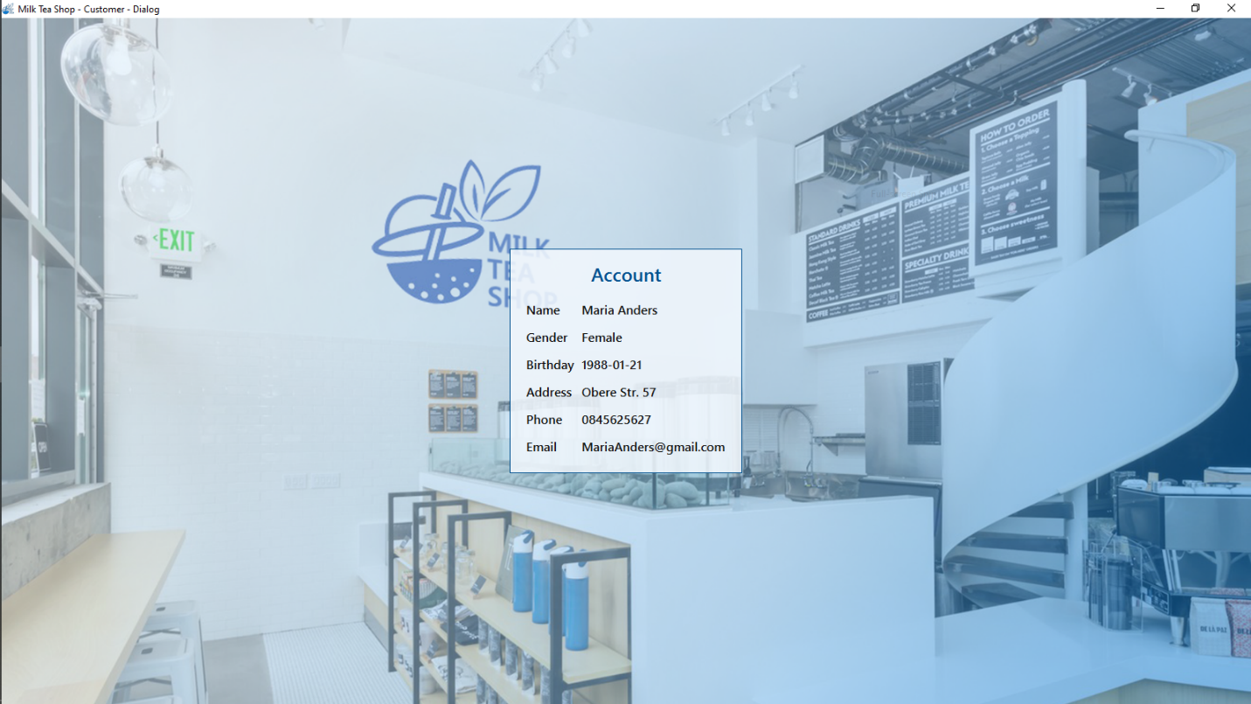

Figure 1: Watch information account form

|  |  |
| --- | --- |
| **Name control** | **Description** |
| Name label | Display name |
| Gender label | Display gender |
| Birthday label | Display birthday |
| Address label | Display address |
| Phone label | Display phone |
| Email label | Display email |

|  |  |  |
| --- | --- | --- |
| **Date:** | **Prepare by (Student)** | **Approve by (Teacher)** |
| **16/10/2019** | **Dao Minh Trung Thuan** | **Luong The Anh** |

|  |  |  |
| --- | --- | --- |
| **Design Plan:** | **Document name: Interface Design Document** | **SWD/Form No.5** |
| **Effective Date:16/10/2019** | **Version: 1** | **Page No:** |

## Change password form

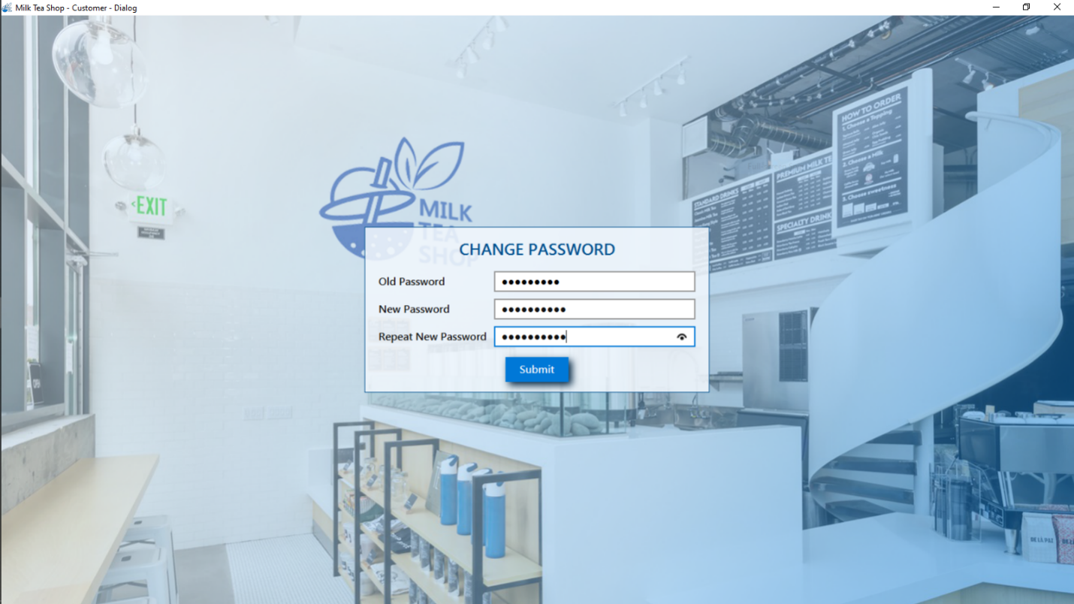

Figure 2: Change password form

|  |  |
| --- | --- |
| **Name control** | **Description** |
| Old password field | Enter old password |
| New password field | Enter new password |
| Repeat password field | Re-enter new password |
| Submit button | Submit for changing password |

|  |  |  |
| --- | --- | --- |
| **Date:** | **Prepare by (Student)** | **Approve by (Teacher)** |
| **16/10/2019** | **Dao Minh Trung Thuan** | **Luong The Anh** |

|  |  |  |
| --- | --- | --- |
| **Design Plan:** | **Document name: Interface Design Document** | **SWD/Form No.5** |
| **Effective Date:16/10/2019** | **Version: 1** | **Page No:** |

## Login form

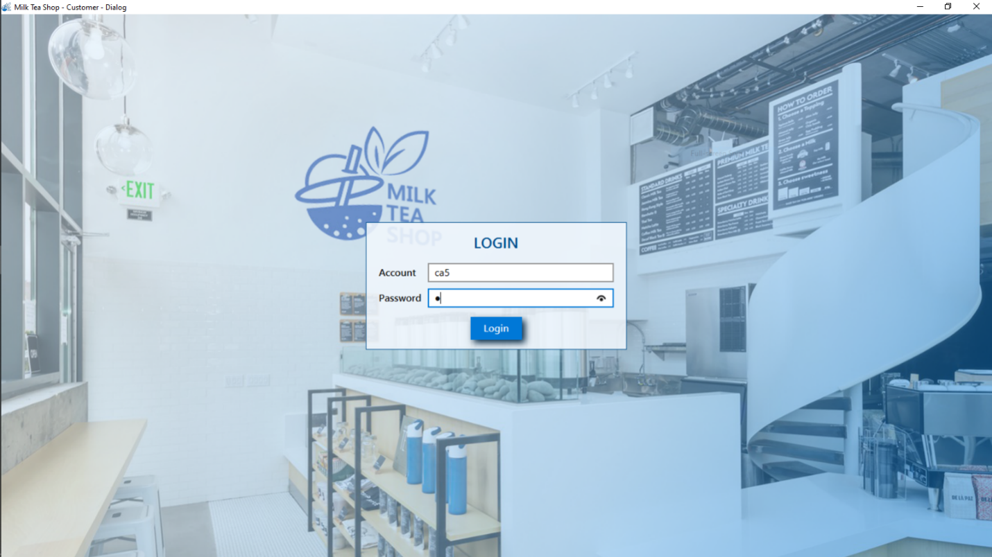

Figure 3: Login form

|  |  |
| --- | --- |
| **Name control** | **Description** |
| Account text field | Enter name account |
| Password field | Enter password |
| Login button | Login system |

|  |  |  |
| --- | --- | --- |
| **Date:** | **Prepare by (Student)** | **Approve by (Teacher)** |
| **16/10/2019** | **Dao Minh Trung Thuan** | **Luong The Anh** |

|  |  |  |
| --- | --- | --- |
| **Design Plan:** | **Document name: Interface Design Document** | **SWD/Form No.5** |
| **Effective Date:16/10/2019** | **Version: 1** | **Page No:** |

## Choose table form

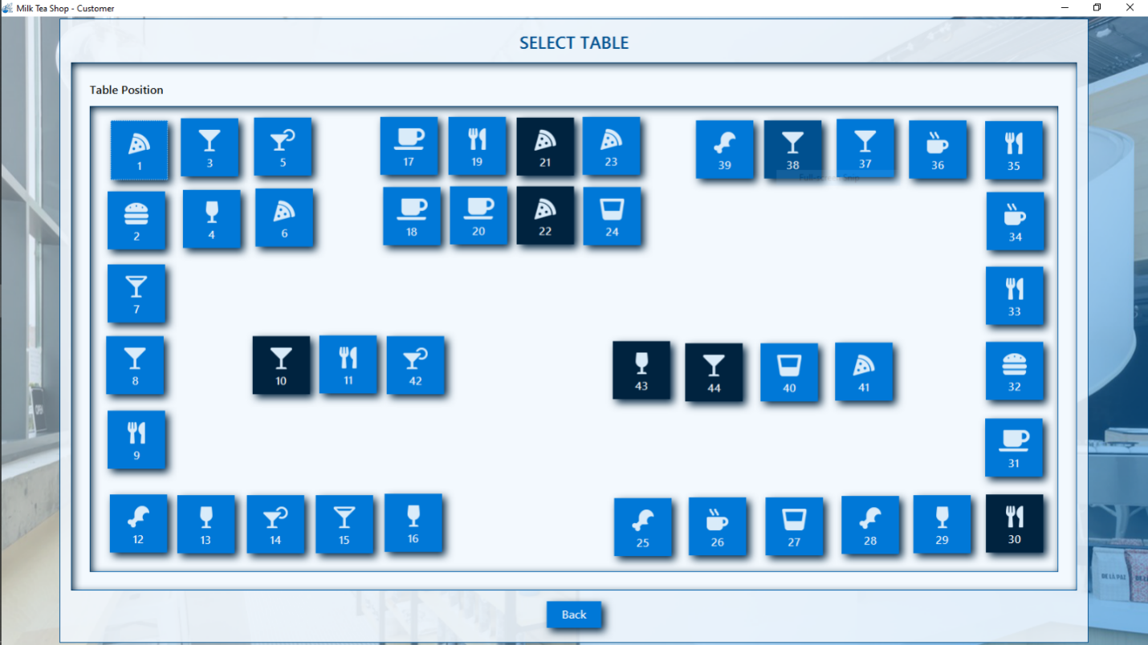

Figure 4: Choose table form

|  |  |
| --- | --- |
| **Name control** | **Description** |
| Table buttons | Choose table to pay bill |
| Back button | Back to order food form |

|  |  |  |
| --- | --- | --- |
| **Date:** | **Prepare by (Student)** | **Approve by (Teacher)** |
| **16/10/2019** | **Dao Minh Trung Thuan** | **Luong The Anh** |

|  |  |  |
| --- | --- | --- |
| **Design Plan:** | **Document name: Interface Design Document** | **SWD/Form No.5** |
| **Effective Date:16/10/2019** | **Version: 1** | **Page No:** |

## Enter discount code form

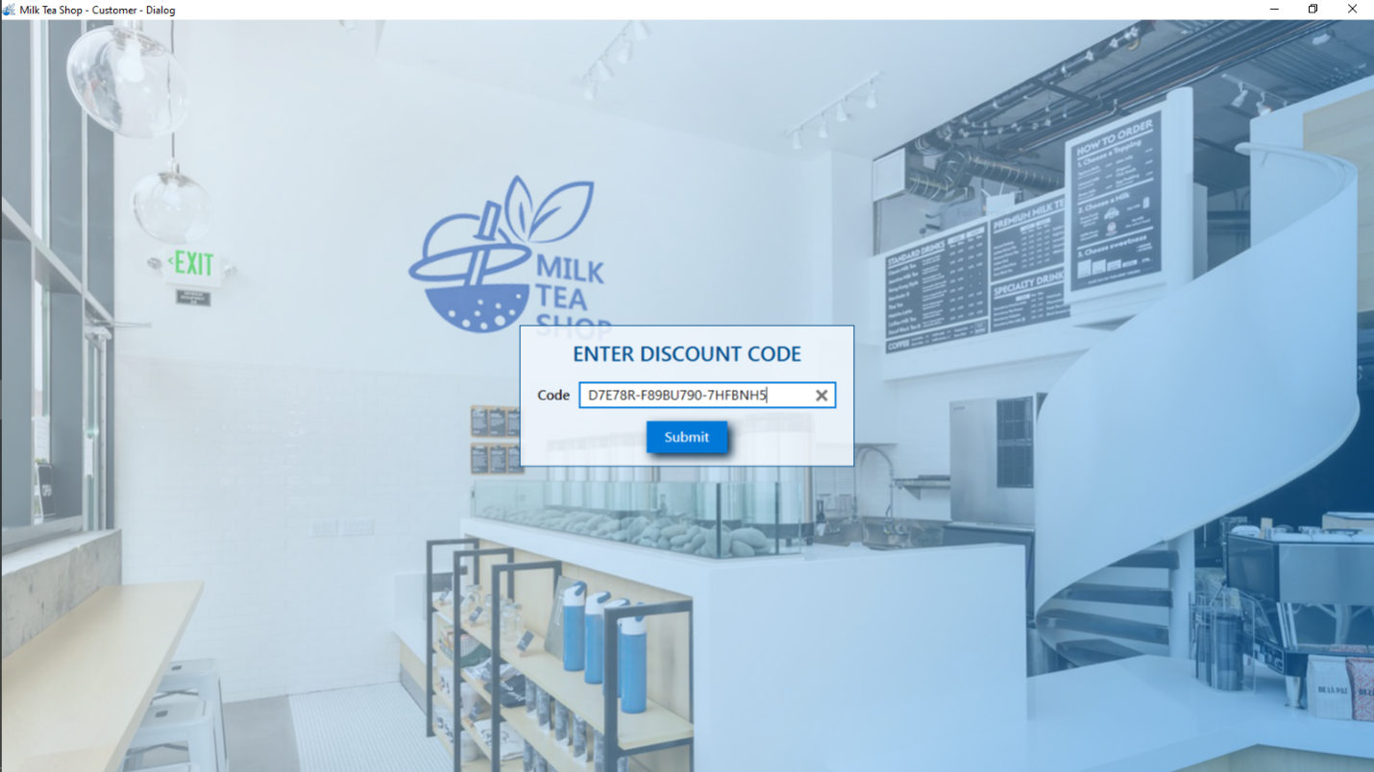

Figure 5: Enter discount code form

|  |  |
| --- | --- |
| **Name control** | **Description** |
| Discount code text field | Enter discount code |
| Submit button | Submit for entering discount code |

|  |  |  |
| --- | --- | --- |
| **Date:** | **Prepare by (Student)** | **Approve by (Teacher)** |
| **16/10/2019** | **Dao Minh Trung Thuan** | **Luong The Anh** |

|  |  |  |
| --- | --- | --- |
| **Design Plan:** | **Document name: Interface Design Document** | **SWD/Form No.5** |
| **Effective Date:16/10/2019** | **Version: 1** | **Page No:** |

## Order food form

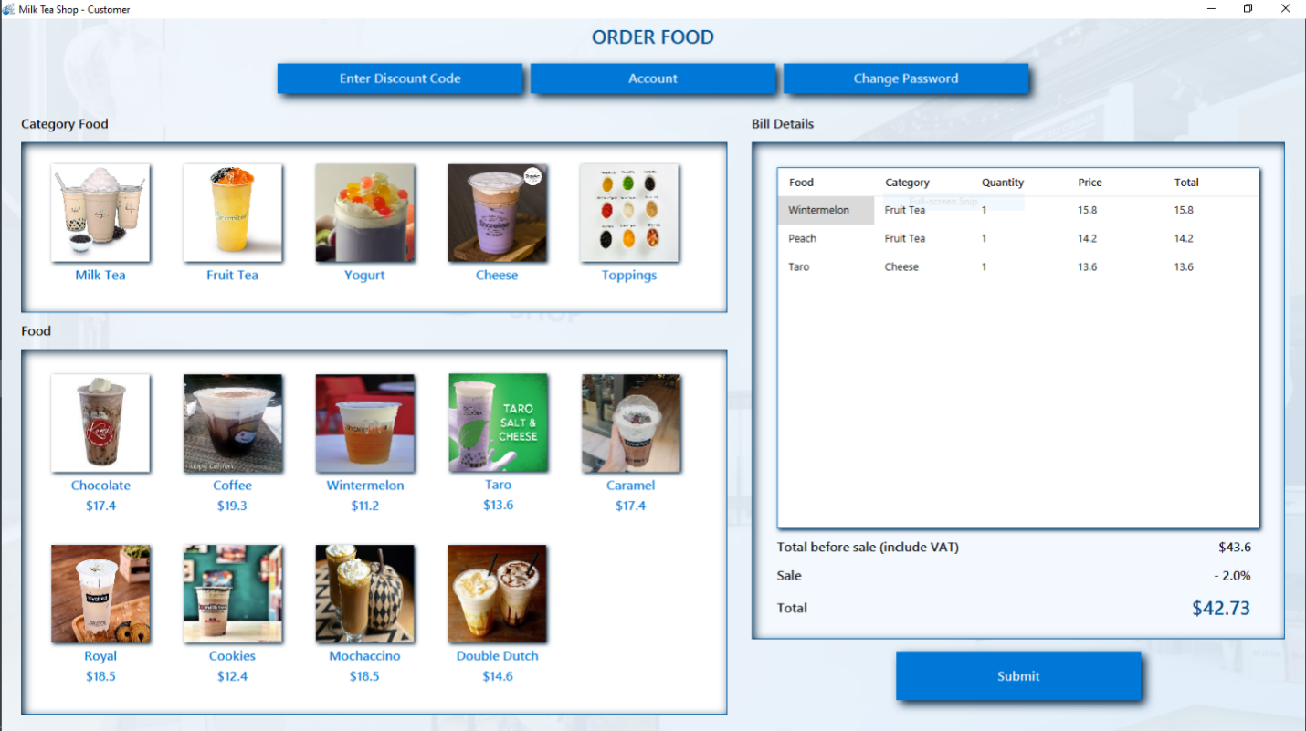

Figure 6: Order food form

|  |  |  |
| --- | --- | --- |
| **Date:** | **Prepare by (Student)** | **Approve by (Teacher)** |
| **16/10/2019** | **Dao Minh Trung Thuan** | **Luong The Anh** |

|  |  |  |
| --- | --- | --- |
| **Design Plan:** | **Document name: Interface Design Document** | **SWD/Form No.5** |
| **Effective Date:16/10/2019** | **Version: 1** | **Page No:** |

|  |  |
| --- | --- |
| **Name control** | **Description** |
| Enter discount code button | Call enter discount code form |
| Account button | Call watch information account form |
| Change password button | Call change password form |
| Category buttons | Load food list by choosing category buttons |
| Food buttons | Order food by choosing food buttons |
| Total before sale label | Display total price before sale |
| Sale label | Display total sale |
| Total label | Display total price after sale |
| Bill view table | Display bill details |
| Submit button | Submit for ordering food |

|  |  |  |
| --- | --- | --- |
| **Date:** | **Prepare by (Student)** | **Approve by (Teacher)** |
| **16/10/2019** | **Dao Minh Trung Thuan** | **Luong The Anh** |

|  |  |  |
| --- | --- | --- |
| **Design Plan:** | **Document name: Interface Design Document** | **SWD/Form No.5** |
| **Effective Date:16/10/2019** | **Version: 1** | **Page No:** |

## Pay bill form

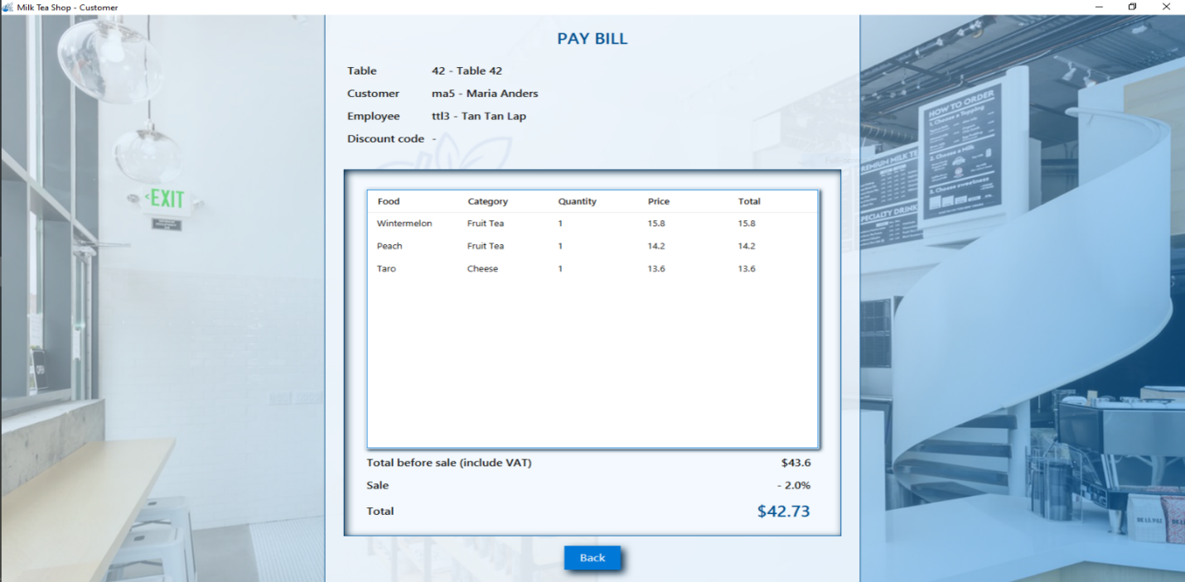

Figure 7: Pay bill form

|  |  |
| --- | --- |
| **Name control** | **Description** |
| Table label | Display chosen table |
| Customer label | Display customer account |
| Employee label | Display employee account |
| Discount code label | Display entered discount code |
| Bill view table | Display bill details |
| Total before sale label | Display total price before sale |
| Sale label | Display total sale |
| Total label | Display total price after sale |
| Back button | Back to form choose table |

|  |  |  |
| --- | --- | --- |
| **Date:** | **Prepare by (Student)** | **Approve by (Teacher)** |
| **16/10/2019** | **Dao Minh Trung Thuan** | **Luong The Anh** |

|  |  |  |
| --- | --- | --- |
| **Design Plan:** | **Document name: Interface Design Document** | **SWD/Form No.5** |
| **Effective Date:16/10/2019** | **Version: 1** | **Page No:** |

## Register form

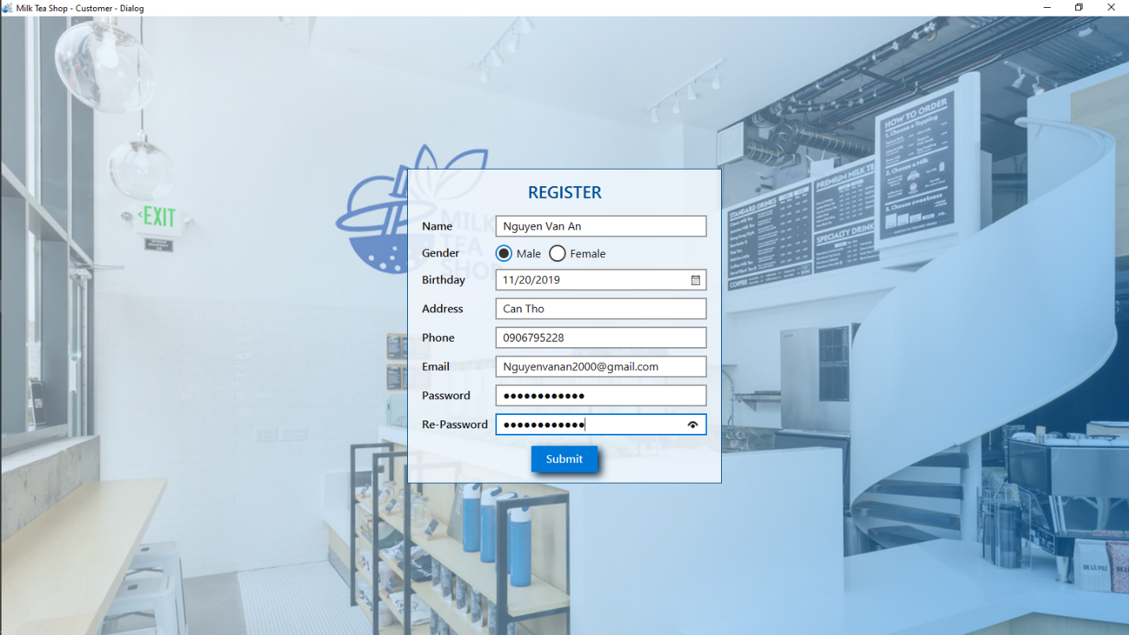

Figure 8: Register form

|  |  |  |
| --- | --- | --- |
| **Date:** | **Prepare by (Student)** | **Approve by (Teacher)** |
| **16/10/2019** | **Dao Minh Trung Thuan** | **Luong The Anh** |

|  |  |  |
| --- | --- | --- |
| **Design Plan:** | **Document name: Interface Design Document** | **SWD/Form No.5** |
| **Effective Date:16/10/2019** | **Version: 1** | **Page No:** |

|  |  |
| --- | --- |
| **Name control** | **Description** |
| Name text field | Enter name |
| Male radio button | Select male gender |
| Female radio button | Select female gender |
| Birthday date picker | Select birthday |
| Address text field | Enter address |
| Phone text field | Enter phone |
| Email text field | Enter email |
| Password field | Enter password |
| Re password field | Re-enter password |
| Submit button | Submit for registering |

|  |  |  |
| --- | --- | --- |
| **Date:** | **Prepare by (Student)** | **Approve by (Teacher)** |
| **16/10/2019** | **Dao Minh Trung Thuan** | **Luong The Anh** |

|  |  |  |
| --- | --- | --- |
| **Design Plan:** | **Document name: Interface Design Document** | **SWD/Form No.5** |
| **Effective Date:16/10/2019** | **Version: 1** | **Page No:** |

## Welcome customer form

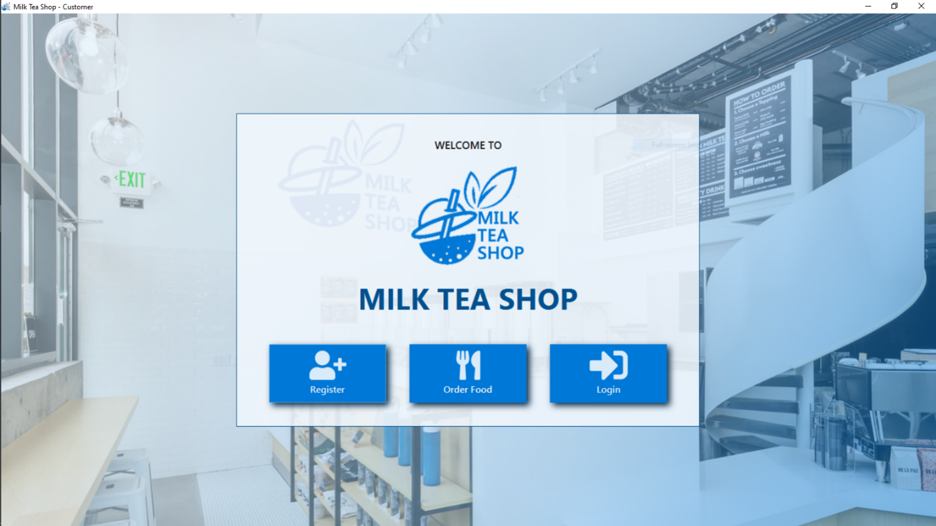

Figure 9: Welcome customer form

|  |  |
| --- | --- |
| **Name control** | **Description** |
| Register button | Call register form |
| Order food button | Call order food form |
| Login button | Call login form |

|  |  |  |
| --- | --- | --- |
| **Date:** | **Prepare by (Student)** | **Approve by (Teacher)** |
| **16/10/2019** | **Dao Minh Trung Thuan** | **Luong The Anh** |

|  |  |  |
| --- | --- | --- |
| **Design Plan:** | **Document name: Interface Design Document** | **SWD/Form No.5** |
| **Effective Date:16/10/2019** | **Version: 1** | **Page No:** |

## Manage order form

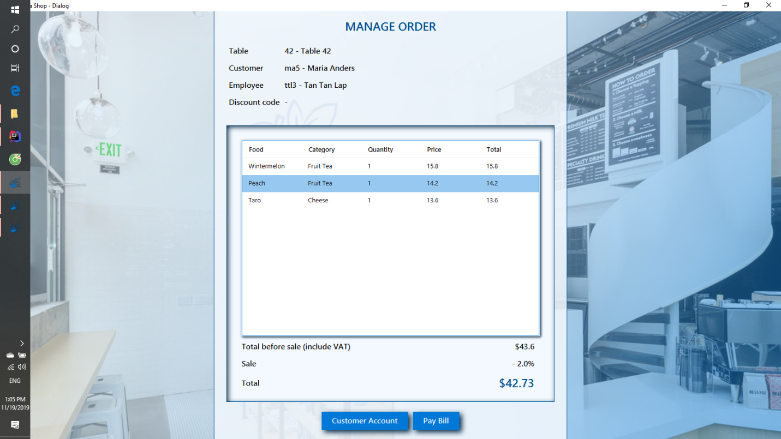

Figure 10: Manage order form

|  |  |  |
| --- | --- | --- |
| **Date:** | **Prepare by (Student)** | **Approve by (Teacher)** |
| **16/10/2019** | **Dao Minh Trung Thuan** | **Luong The Anh** |

|  |  |  |
| --- | --- | --- |
| **Design Plan:** | **Document name: Interface Design Document** | **SWD/Form No.5** |
| **Effective Date:16/10/2019** | **Version: 1** | **Page No:** |

|  |  |
| --- | --- |
| **Name control** | **Description** |
| Table label | Display chosen table |
| Customer label | Display customer account |
| Employee label | Display employee account |
| Discount code label | Display entered discount code |
| Bill view table | Display bill details |
| Total before sale label | Display total price before sale |
| Sale label | Display total sale |
| Total label | Display total price after sale |
| Customer account button | Call watch customer account form |
| Pay bill | Check in bill |

|  |  |  |
| --- | --- | --- |
| **Date:** | **Prepare by (Student)** | **Approve by (Teacher)** |
| **16/10/2019** | **Dao Minh Trung Thuan** | **Luong The Anh** |

|  |  |  |
| --- | --- | --- |
| **Design Plan:** | **Document name: Interface Design Document** | **SWD/Form No.5** |
| **Effective Date:16/10/2019** | **Version: 1** | **Page No:** |

## Manage shop form for employee

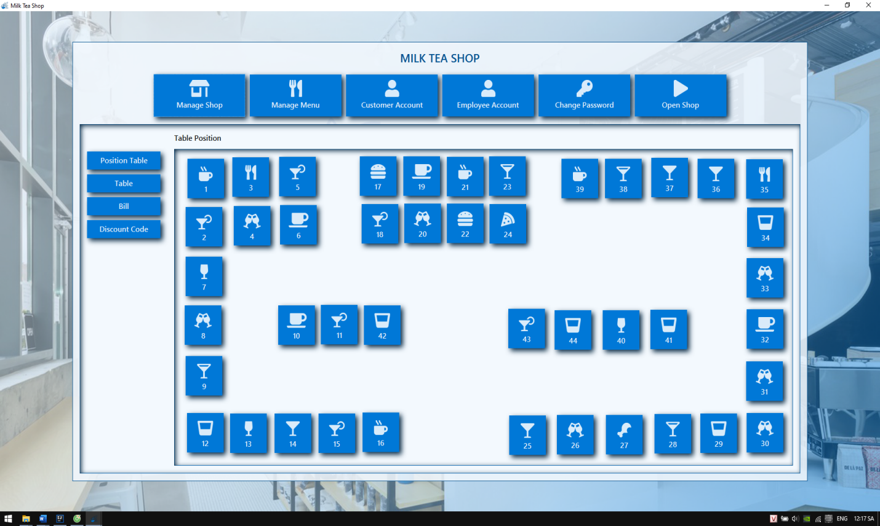

Figure 11: Employee form

|  |  |  |
| --- | --- | --- |
| **Date:** | **Prepare by (Student)** | **Approve by (Teacher)** |
| **16/10/2019** | **Dao Minh Trung Thuan** | **Luong The Anh** |

|  |  |  |
| --- | --- | --- |
| **Design Plan:** | **Document name: Interface Design Document** | **SWD/Form No.5** |
| **Effective Date:16/10/2019** | **Version: 1** | **Page No:** |

|  |  |
| --- | --- |
| **Name control** | **Description** |
| Manage Shop | Call manage shop form |
| Manage menu | Call manage menu form |
| Customer account button | Call manage customer form |
| Employee account button | Call watch information account form |
| Change password button | Call change password form |
| Open shop button | Setup position customer form |
| Manage position table button | Call manage position table form |
| Manage table button | Call manage table form |
| Manage bill button | Call manage bill form |
| Discount code button | Call manage discount code button |
| Table buttons | Display table in shop |

|  |  |  |
| --- | --- | --- |
| **Date:** | **Prepare by (Student)** | **Approve by (Teacher)** |
| **16/10/2019** | **Dao Minh Trung Thuan** | **Luong The Anh** |

|  |  |  |
| --- | --- | --- |
| **Design Plan:** | **Document name: Interface Design Document** | **SWD/Form No.5** |
| **Effective Date:16/10/2019** | **Version: 1** | **Page No:** |

## Manage table form

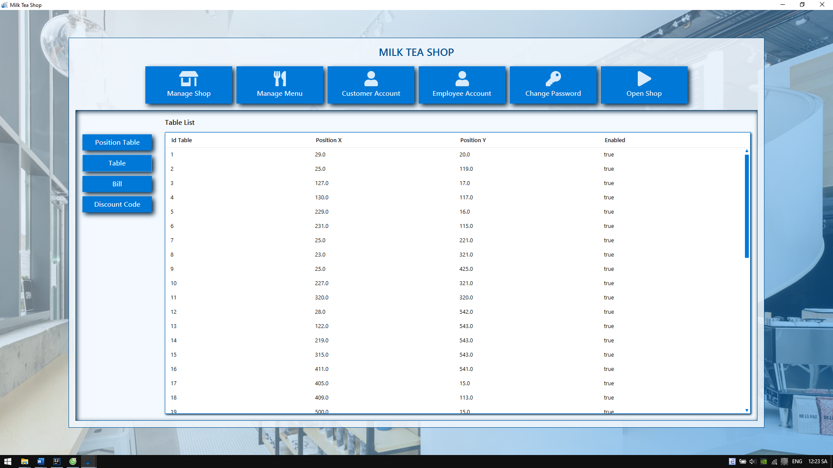

Figure 12 Manage table form

|  |  |
| --- | --- |
| **Name control** | **Description** |
| Table list view table | Display table list |

|  |  |  |
| --- | --- | --- |
| **Date:** | **Prepare by (Student)** | **Approve by (Teacher)** |
| **16/10/2019** | **Dao Minh Trung Thuan** | **Luong The Anh** |

|  |  |  |
| --- | --- | --- |
| **Design Plan:** | **Document name: Interface Design Document** | **SWD/Form No.5** |
| **Effective Date:16/10/2019** | **Version: 1** | **Page No:** |

## Manage bill form

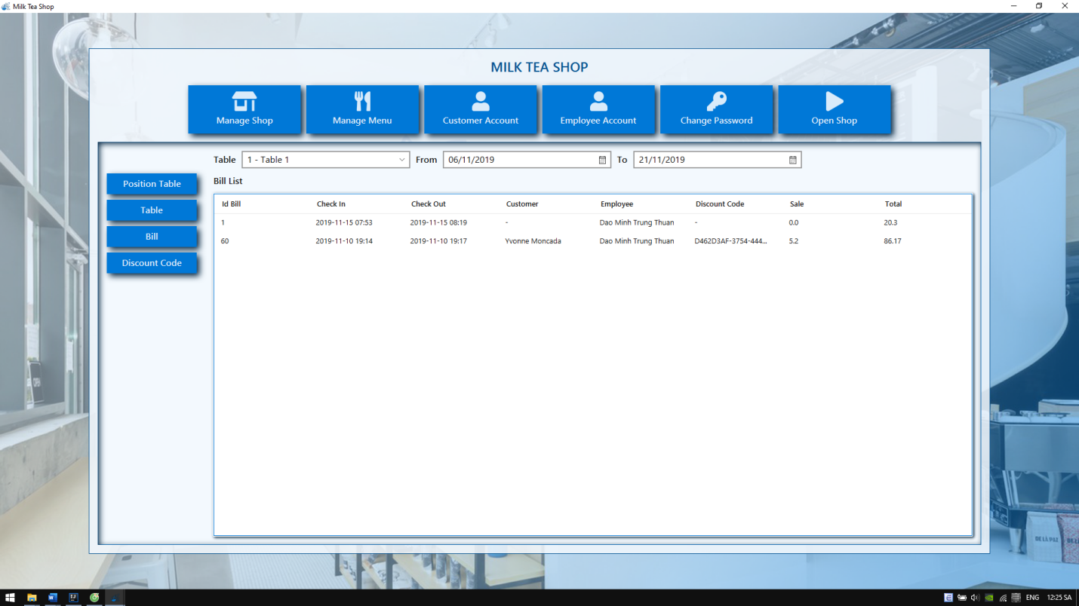

Figure 13 Manage bill form

|  |  |
| --- | --- |
| **Name control** | **Description** |
| Bill list view table | Display bill list |
| Table combo box | Select table for showing bill list |
| From date picker | Select date starting |
| To date picker | Select date ending |

|  |  |  |
| --- | --- | --- |
| **Date:** | **Prepare by (Student)** | **Approve by (Teacher)** |
| **16/10/2019** | **Dao Minh Trung Thuan** | **Luong The Anh** |

|  |  |  |
| --- | --- | --- |
| **Design Plan:** | **Document name: Interface Design Document** | **SWD/Form No.5** |
| **Effective Date:16/10/2019** | **Version: 1** | **Page No:** |

## Manage discount code form

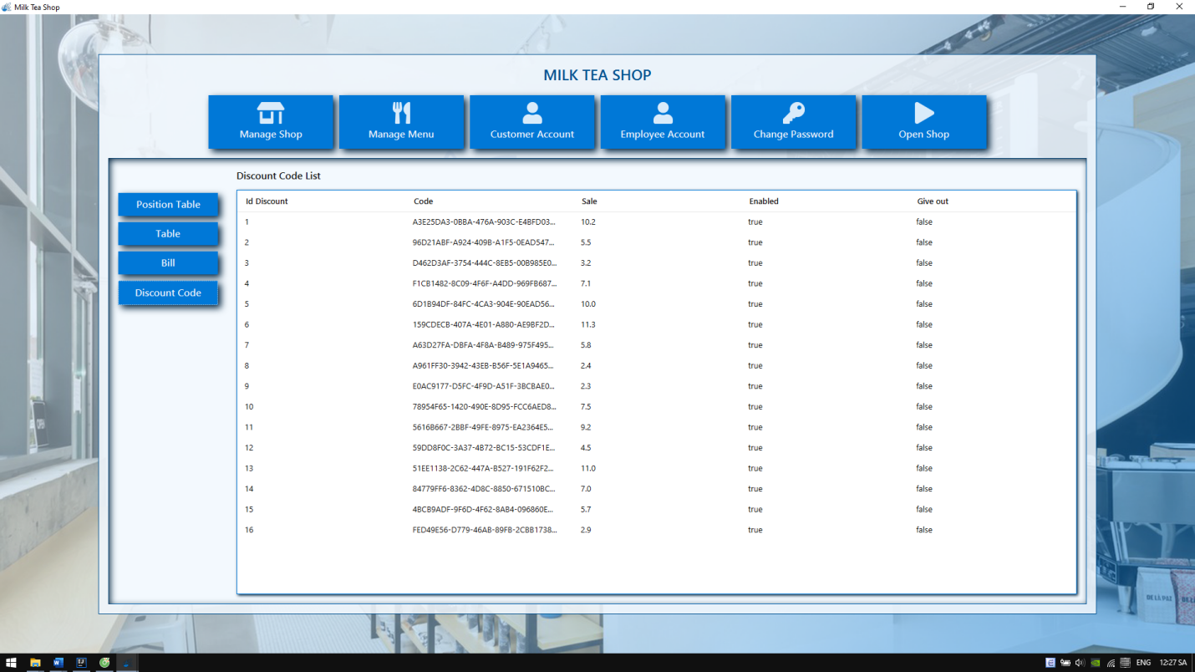

Figure 14: Manage discount code form

|  |  |
| --- | --- |
| **Name control** | **Description** |
| Discount code list view table | Display discount code list |

|  |  |  |
| --- | --- | --- |
| **Date:** | **Prepare by (Student)** | **Approve by (Teacher)** |
| **16/10/2019** | **Dao Minh Trung Thuan** | **Luong The Anh** |

|  |  |  |
| --- | --- | --- |
| **Design Plan:** | **Document name: Interface Design Document** | **SWD/Form No.5** |
| **Effective Date:16/10/2019** | **Version: 1** | **Page No:** |

## Manage menu form

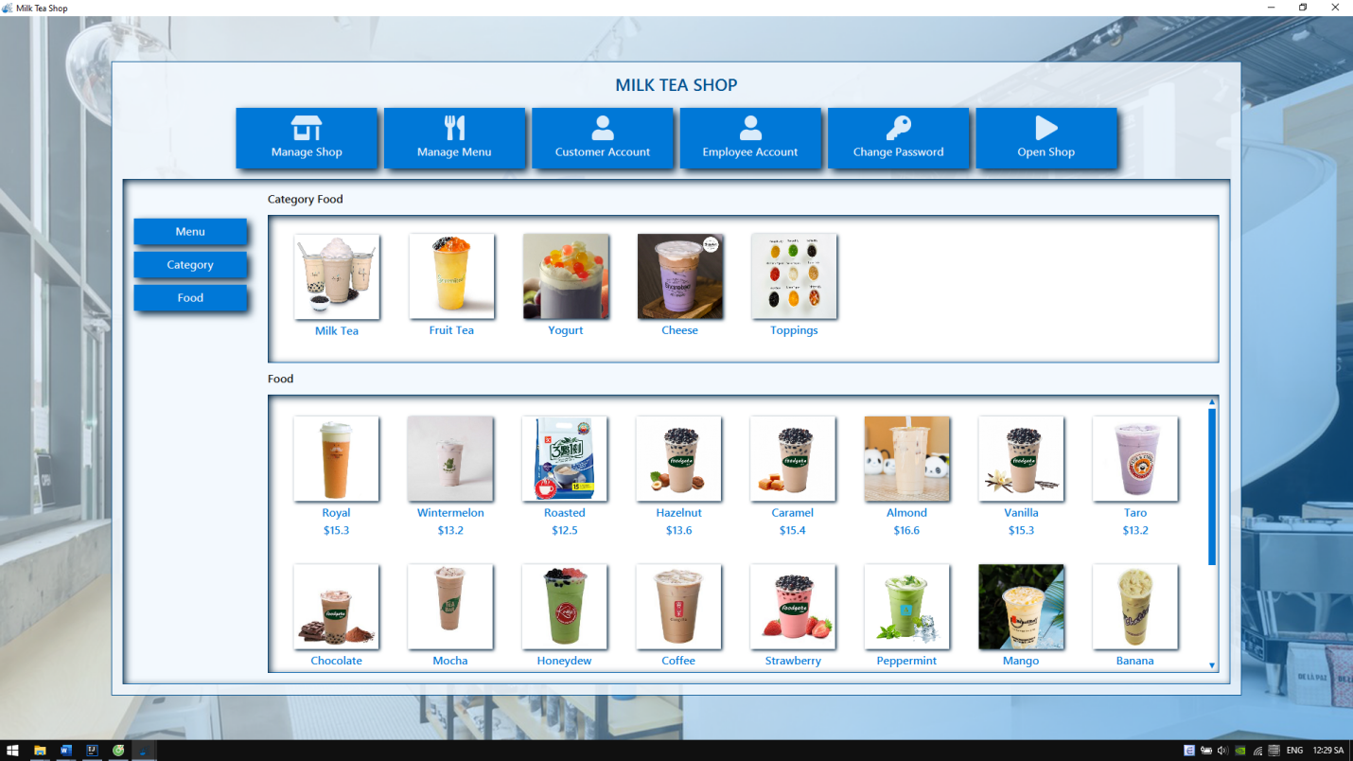

Figure 15: Manage menu form

|  |  |
| --- | --- |
| **Name control** | **Description** |
| Manage menu button | Call manage menu form |
| Manage category button | Call manage category form |
| Manage food button | Call manage food form |
| Category buttons | Display category list |
| Food buttons | Display food list |

|  |  |  |
| --- | --- | --- |
| **Date:** | **Prepare by (Student)** | **Approve by (Teacher)** |
| **16/10/2019** | **Dao Minh Trung Thuan** | **Luong The Anh** |

|  |  |  |
| --- | --- | --- |
| **Design Plan:** | **Document name: Interface Design Document** | **SWD/Form No.5** |
| **Effective Date:16/10/2019** | **Version: 1** | **Page No:** |

## Manage category form

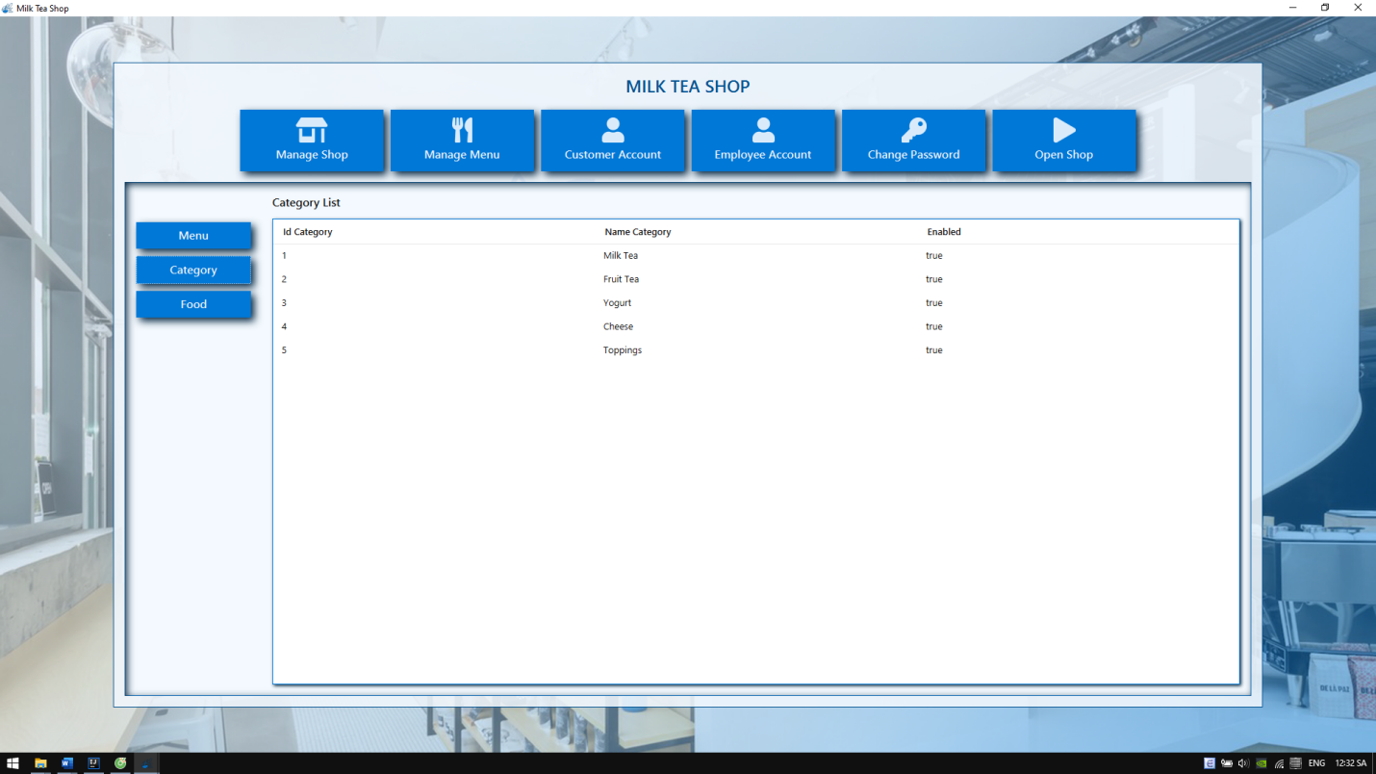

Figure 16: Manage category form

|  |  |
| --- | --- |
| **Name control** | **Description** |
| Category list view table | Display category list |

|  |  |  |
| --- | --- | --- |
| **Date:** | **Prepare by (Student)** | **Approve by (Teacher)** |
| **16/10/2019** | **Dao Minh Trung Thuan** | **Luong The Anh** |

|  |  |  |
| --- | --- | --- |
| **Design Plan:** | **Document name: Interface Design Document** | **SWD/Form No.5** |
| **Effective Date:16/10/2019** | **Version: 1** | **Page No:** |

## Manage food form

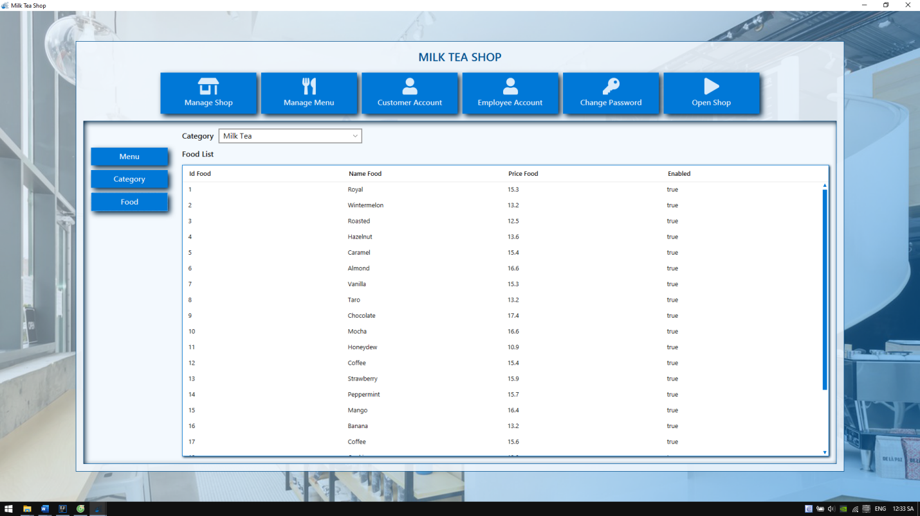

Figure 17: Manage food form

|  |  |
| --- | --- |
| **Name control** | **Description** |
| Food list view table | Display food list |
| Category combo box | Select category for showing food |

|  |  |  |
| --- | --- | --- |
| **Date:** | **Prepare by (Student)** | **Approve by (Teacher)** |
| **16/10/2019** | **Dao Minh Trung Thuan** | **Luong The Anh** |

|  |  |  |
| --- | --- | --- |
| **Design Plan:** | **Document name: Interface Design Document** | **SWD/Form No.5** |
| **Effective Date:16/10/2019** | **Version: 1** | **Page No:** |

## Manage customer account form

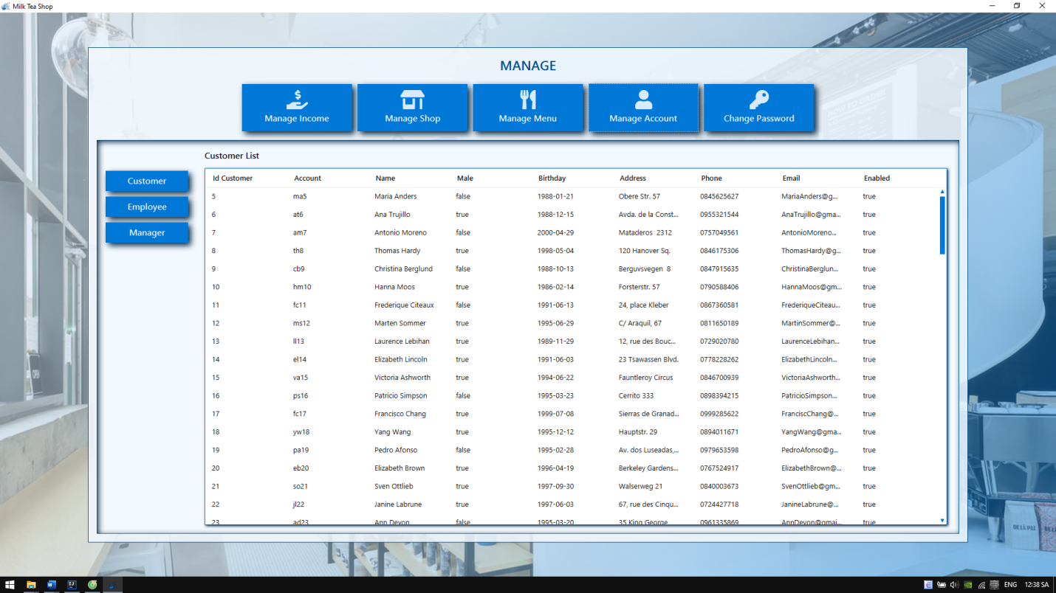

Figure 18: Manage customer account form

|  |  |
| --- | --- |
| **Name control** | **Description** |
| Customer list view table | Display customer account list |
| Manage customer account button | Call customer account form |
| Manage employee account button | Call employee account form |
| Manage manager account button | Call manager account form |

|  |  |  |
| --- | --- | --- |
| **Date:** | **Prepare by (Student)** | **Approve by (Teacher)** |
| **16/10/2019** | **Dao Minh Trung Thuan** | **Luong The Anh** |

|  |  |  |
| --- | --- | --- |
| **Design Plan:** | **Document name: Interface Design Document** | **SWD/Form No.5** |
| **Effective Date:16/10/2019** | **Version: 1** | **Page No:** |

## Manage employee account form

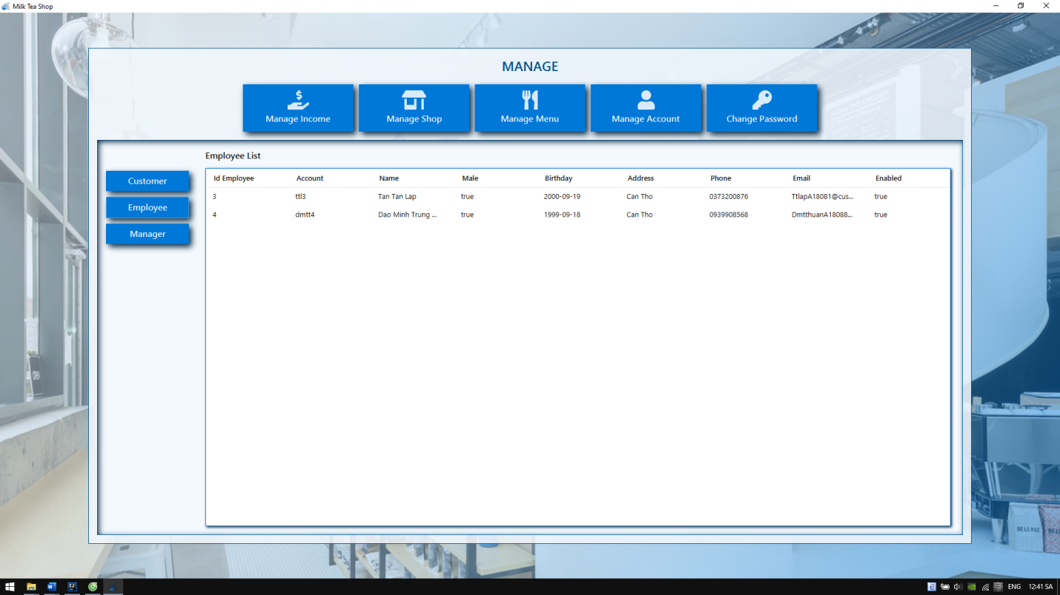

Figure 19: Manage employee account form

|  |  |
| --- | --- |
| **Name control** | **Description** |
| Employee list view table | Display employee account list |

|  |  |  |
| --- | --- | --- |
| **Date:** | **Prepare by (Student)** | **Approve by (Teacher)** |
| **16/10/2019** | **Dao Minh Trung Thuan** | **Luong The Anh** |

|  |  |  |
| --- | --- | --- |
| **Design Plan:** | **Document name: Interface Design Document** | **SWD/Form No.5** |
| **Effective Date:16/10/2019** | **Version: 1** | **Page No:** |

## Manage manager account form

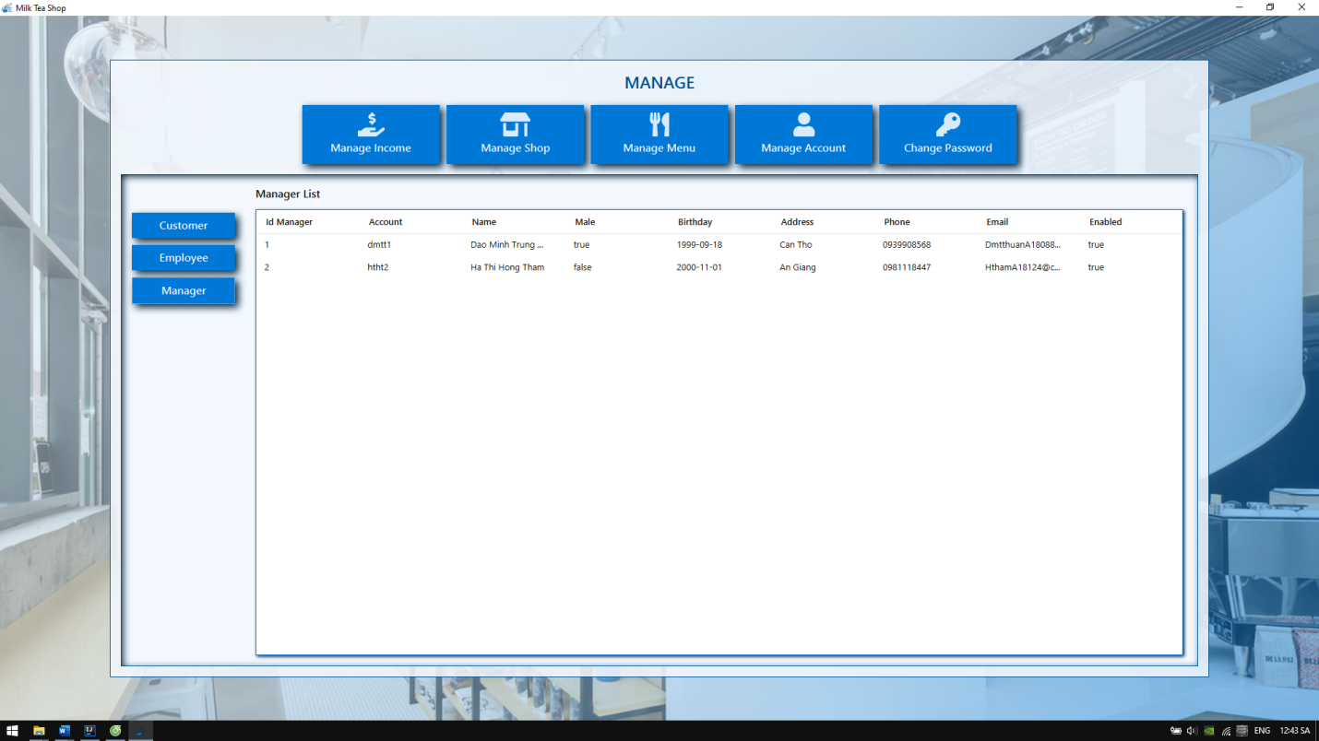

Figure 20: Manage manager account form

|  |  |
| --- | --- |
| **Name control** | **Description** |
| Manager list view table | Display manager account list |

|  |  |  |
| --- | --- | --- |
| **Date:** | **Prepare by (Student)** | **Approve by (Teacher)** |
| **16/10/2019** | **Dao Minh Trung Thuan** | **Luong The Anh** |

|  |  |  |
| --- | --- | --- |
| **Design Plan:** | **Document name: Interface Design Document** | **SWD/Form No.5** |
| **Effective Date:16/10/2019** | **Version: 1** | **Page No:** |

|  |  |  |
| --- | --- | --- |
| **Date:** | **Prepare by (Student)** | **Approve by (Teacher)** |
| **16/10/2019** | **Dao Minh Trung Thuan** | **Luong The Anh** |

## Manage income form

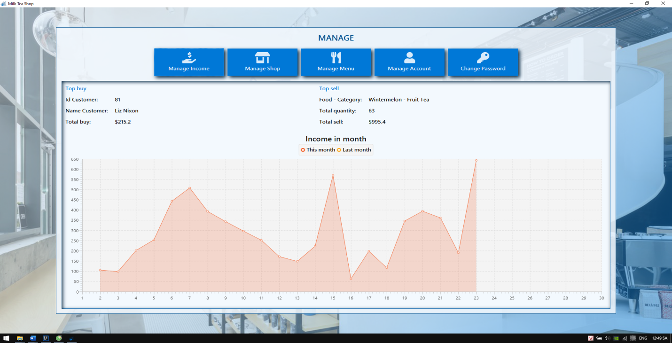

Figure 21 Manage income form

|  |  |
| --- | --- |
| **Name control** | **Description** |
| Id customer label | Display id of top customer |
| Nam customer label | Display name of top customer |
| Total buy label | Display total buy of top customer |
| Food label | Display name food and category of top food |
| Total quantity label | Display total quantity of top food |
| Total sale label | Display total sale of top food |
| Income area chart | Display income this month and last month |

|  |  |  |
| --- | --- | --- |
| **Design Plan:** | **Document name: Document Design** | **SWD/Form No.6** |
| **Effective Date: 16/10/2019** | **Version: 1** | **Page No:** |

# TABLE DESIGN DOCUMENTATION

|  |  |  |  |  |  |
| --- | --- | --- | --- | --- | --- |
| **Name of the Table** | **Table Description** | **Number of Fields** | **Primary Key** | **Related Tables** | **Foreign Key** |
| Account | User account in the system. | 11 | id |  |  |
| Table | Information of table. | 4 | id |  |  |
| Category | Category of food. | 3 | id |  |  |
| Food | Information of food. | 5 | id | 1. Category | idCategory |
| Discount | Information of discount. | 4 | id |  |  |
| Bill | Information of bill. | 8 | id | 1. Table  2. Account  3. Discount | idTable  idCustomer  idEmployee  idDiscount |
| BillDetail | Information of bill detail. | 8 | id | Bill | idBill |

|  |  |  |
| --- | --- | --- |
| **Date:** | **Prepare by (Student)** | **Approve by (Teacher)** |
| **22/10/2019** | **Ha Thi Hong Tham** | **Luong The Anh** |

|  |  |  |
| --- | --- | --- |
| **Design Plan:** | **Document name: Document Design** | **SWD/Form No.6** |
| **Effective Date: 16/10/2019** | **Version: 1** | **Page No:** |

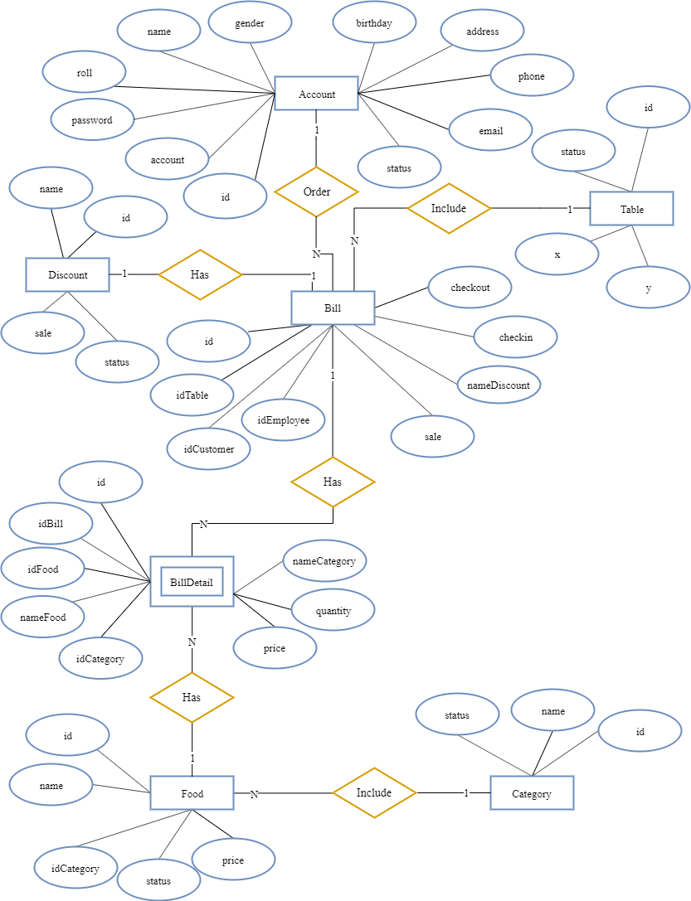

Figure 22: Entity relationship diagram

|  |  |  |
| --- | --- | --- |
| **Date:** | **Prepare by (Student)** | **Approve by (Teacher)** |
| **22/10/2019** | **Ha Thi Hong Tham** | **Luong The Anh** |

|  |  |  |
| --- | --- | --- |
| **Design Plan:** | **Document name: Process Design Document** | **SWD/Form No.7** |
| **Effective Date: 22/10/2019** | **Version: 1** | **Page No:** |

# PROCESS DESIGN DOCUMENTATION

## Context level

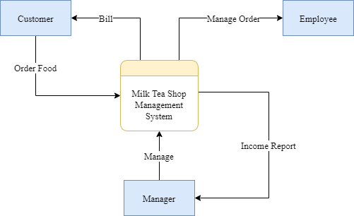

Figure 23: Context level data flow diagram

|  |  |  |
| --- | --- | --- |
| **Date:** | **Prepare by (Student)** | **Approve by (Teacher)** |
| **22/10/2019** | **Tan Tan Lap** | **Luong The Anh** |

|  |  |  |
| --- | --- | --- |
| **Design Plan:** | **Document name: Process Design Document** | **SWD/Form No.7** |
| **Effective Date: 22/10/2019** | **Version: 1** | **Page No:** |

## Level 0

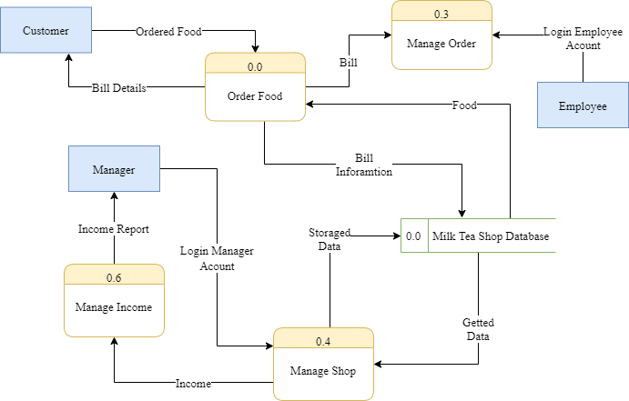

Figure 24: Level 0 data flow diagram

## Level 1

### Customer

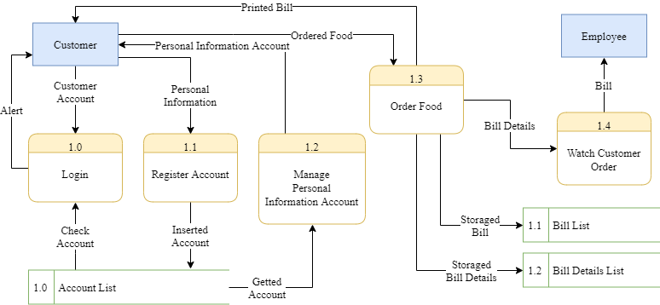

Figure 25: Level 1 data flow diagram for customer

|  |  |  |
| --- | --- | --- |
| **Date:** | **Prepare by (Student)** | **Approve by (Teacher)** |
| **22/10/2019** | **Tan Tan Lap** | **Luong The Anh** |

|  |  |  |
| --- | --- | --- |
| **Design Plan:** | **Document name: Process Design Document** | **SWD/Form No.7** |
| **Effective Date: 22/10/2019** | **Version: 1** | **Page No:** |

### Employee

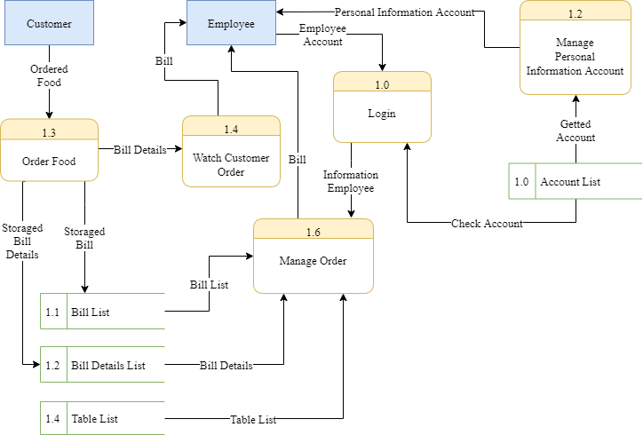

Figure 26: Level 1 data flow diagram for employee

|  |  |  |
| --- | --- | --- |
| **Date:** | **Prepare by (Student)** | **Approve by (Teacher)** |
| **22/10/2019** | **Tan Tan Lap** | **Luong The Anh** |

|  |  |  |
| --- | --- | --- |
| **Design Plan:** | **Document name: Process Design Document** | **SWD/Form No.7** |
| **Effective Date: 22/10/2019** | **Version: 1** | **Page No:** |

### Manager

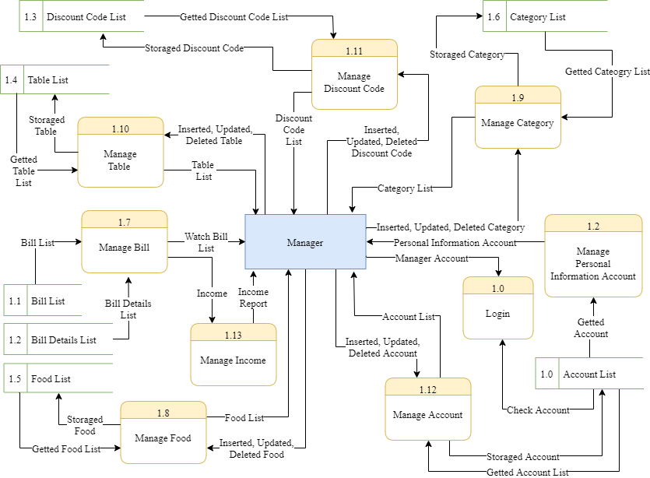

Figure 27: Level 1 data flow diagram for manager

|  |  |  |
| --- | --- | --- |
| **Date:** | **Prepare by (Student)** | **Approve by (Teacher)** |
| **22/10/2019** | **Tan Tan Lap** | **Luong The Anh** |

|  |  |  |
| --- | --- | --- |
| **Design Plan:** | **Document name: Process Design Document** | **SWD/Form No.7** |
| **Effective Date: 22/10/2019** | **Version: 1** | **Page No:** |

## Level 2

### Customer

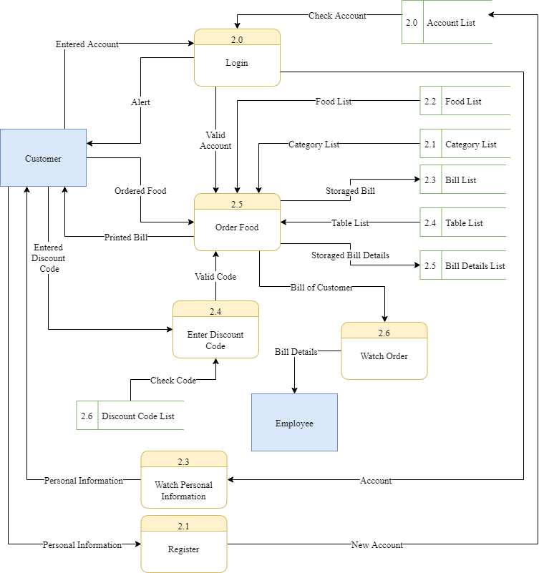

Figure 28: Level 2 data flow diagram for customer

|  |  |  |
| --- | --- | --- |
| **Date:** | **Prepare by (Student)** | **Approve by (Teacher)** |
| **22/10/2019** | **Tan Tan Lap** | **Luong The Anh** |

|  |  |  |
| --- | --- | --- |
| **Design Plan:** | **Document name: Process Design Document** | **SWD/Form No.7** |
| **Effective Date: 22/10/2019** | **Version: 1** | **Page No:** |

### Employee

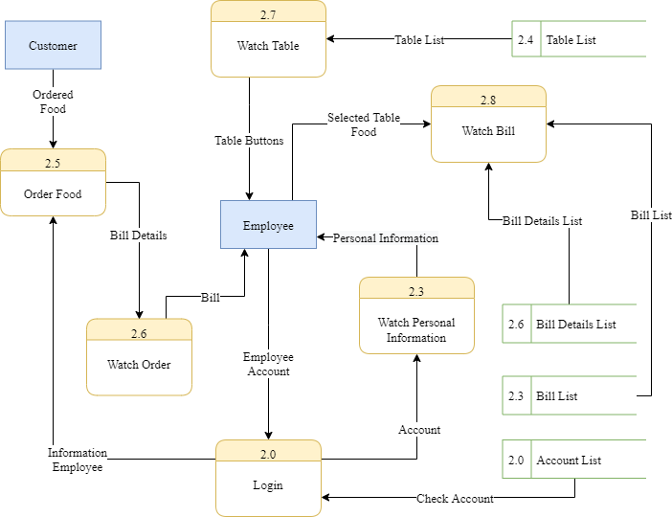

Figure 29: Level 2 data flow diagram for employee

|  |  |  |
| --- | --- | --- |
| **Date:** | **Prepare by (Student)** | **Approve by (Teacher)** |
| **22/10/2019** | **Tan Tan Lap** | **Luong The Anh** |

|  |  |  |
| --- | --- | --- |
| **Design Plan:** | **Document name: Process Design Document** | **SWD/Form No.7** |
| **Effective Date: 22/10/2019** | **Version: 1** | **Page No:** |

### Manager

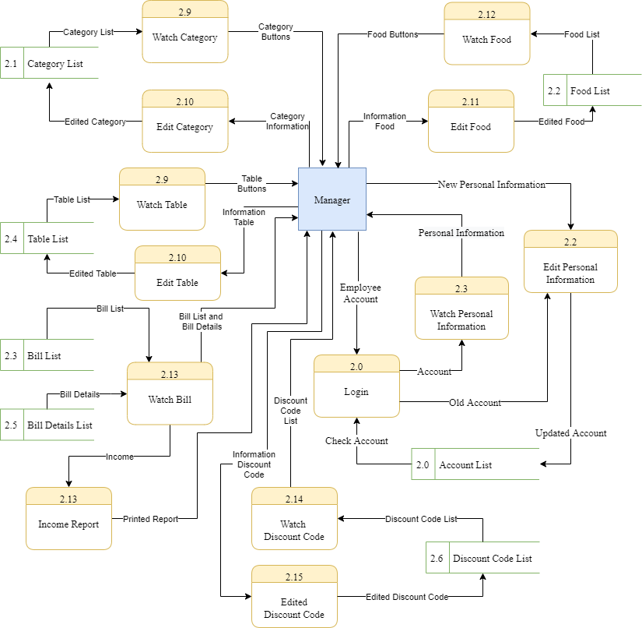

Figure 30: Level 2 data flow diagram for manager

|  |  |  |
| --- | --- | --- |
| **Date:** | **Prepare by (Student)** | **Approve by (Teacher)** |
| **22/10/2019** | **Tan Tan Lap** | **Luong The Anh** |

|  |  |  |
| --- | --- | --- |
| **Design Plan:** | **Document name: Process Design Document** | **SWD/Form No.7** |
| **Effective Date: 22/10/2019** | **Version: 1** | **Page No:** |

## Level 3 for Order food process

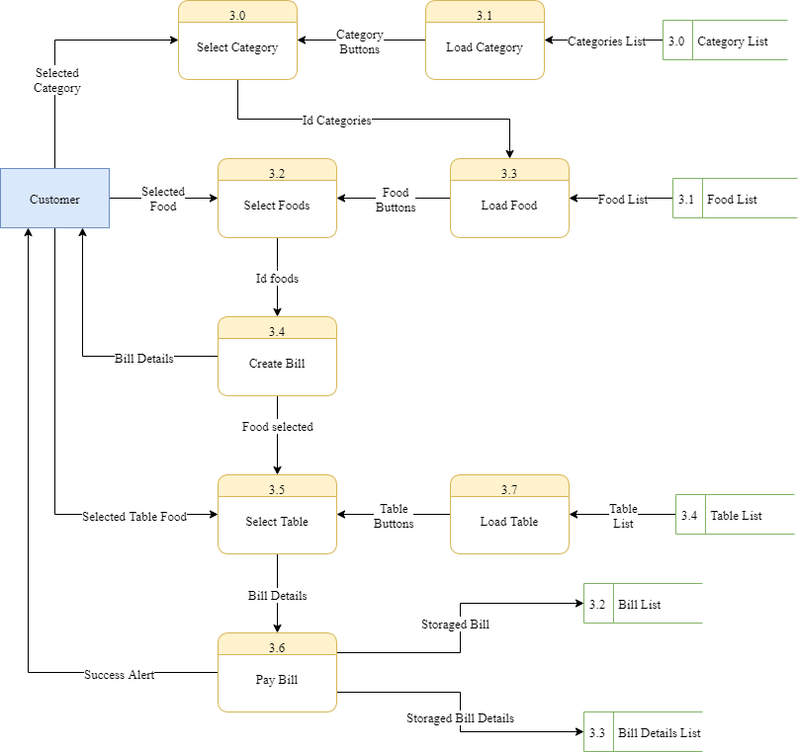

Figure 31: Level 3 data flow diagram for Order food process

|  |  |  |
| --- | --- | --- |
| **Date:** | **Prepare by (Student)** | **Approve by (Teacher)** |
| **22/10/2019** | **Tan Tan Lap** | **Luong The Anh** |

|  |  |  |
| --- | --- | --- |
| **Design Plan:** | **Document name: Process Design Document** | **SWD/Form No.7** |
| **Effective Date: 22/10/2019** | **Version: 1** | **Page No:** |

## Flow chart diagram

### Change password process

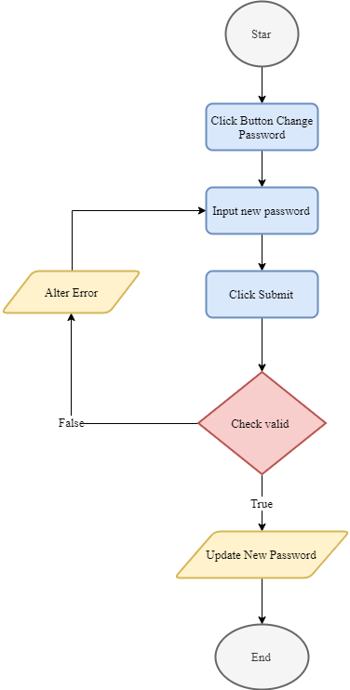

Figure 32: Change password process

|  |  |  |
| --- | --- | --- |
| **Date:** | **Prepare by (Student)** | **Approve by (Teacher)** |
| **22/10/2019** | **Tan Tan Lap** | **Luong The Anh** |

|  |  |  |
| --- | --- | --- |
| **Design Plan:** | **Document name: Process Design Document** | **SWD/Form No.7** |
| **Effective Date: 22/10/2019** | **Version: 1** | **Page No:** |

### Login process

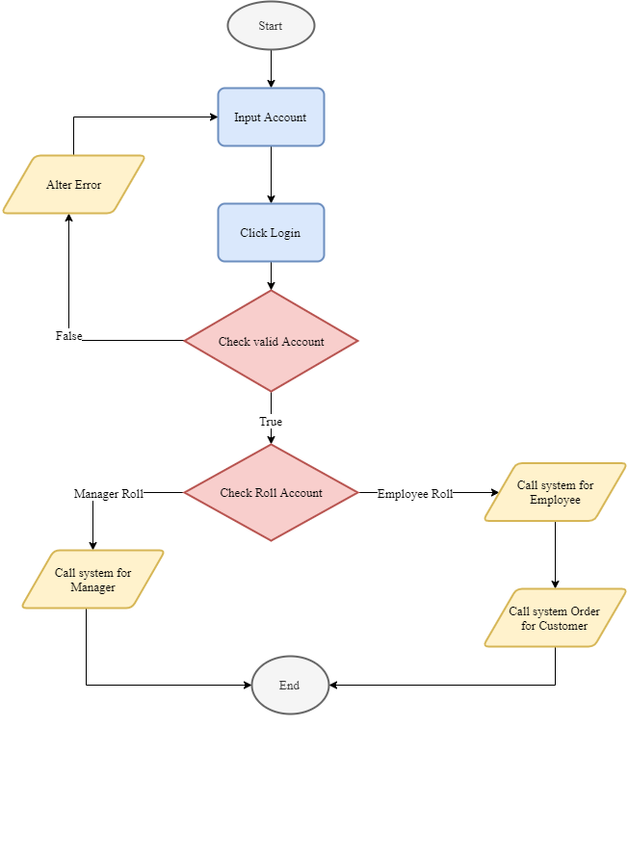

Figure 33: Login process

|  |  |  |
| --- | --- | --- |
| **Date:** | **Prepare by (Student)** | **Approve by (Teacher)** |
| **22/10/2019** | **Tan Tan Lap** | **Luong The Anh** |

|  |  |  |
| --- | --- | --- |
| **Design Plan:** | **Document name: Process Design Document** | **SWD/Form No.7** |
| **Effective Date: 22/10/2019** | **Version: 1** | **Page No:** |

### Manage order process

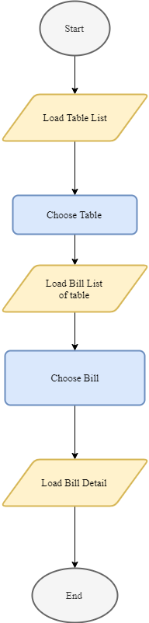

Figure 34: Manage order process

|  |  |  |
| --- | --- | --- |
| **Date:** | **Prepare by (Student)** | **Approve by (Teacher)** |
| **22/10/2019** | **Tan Tan Lap** | **Luong The Anh** |

|  |  |  |
| --- | --- | --- |
| **Design Plan:** | **Document name: Process Design Document** | **SWD/Form No.7** |
| **Effective Date: 22/10/2019** | **Version: 1** | **Page No:** |

### Register process

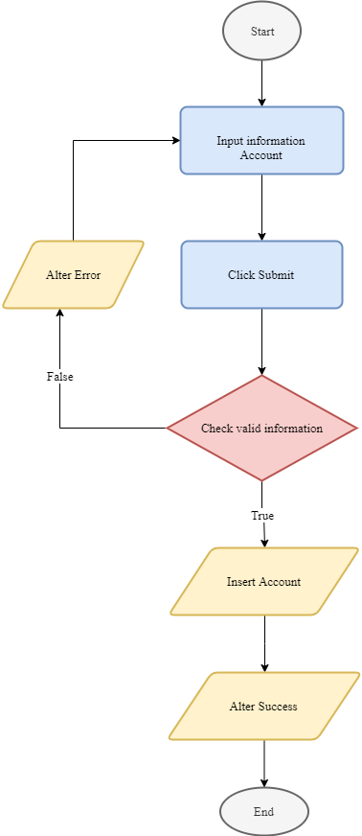

Figure 35: Register process

|  |  |  |
| --- | --- | --- |
| **Date:** | **Prepare by (Student)** | **Approve by (Teacher)** |
| **22/10/2019** | **Tan Tan Lap** | **Luong The Anh** |

|  |  |  |
| --- | --- | --- |
| **Design Plan:** | **Document name: Coding Standards Document** | **SWD/Form No.8** |
| **Effective Date: 22/10/2019** | **Version: 1** | **Page No:** |

# CODING STANDARD DOCUMENTATION

## Programming Standards.

* Every button should have an Icon for expressing, image icons have to store in the folder at source “<ProjectName>/src/asset” and have extension is “.png”.
* Must have declaration part for classes and interfaces using for the project.

## Standards for code writing style

* The package name should be in all lowercase letters. Example: controller, view.
* Names for data types must be nouns, and be spelled out by words that begin with an uppercase character. Example: ViewLogin, ViewChangePassword.
* Variable names must start with a lowercase letter, the next words begin with a capital letter. Example: name, controllerLogin.
* The constant name must be all capital letters, words separated by underscore "_". Example: CONNECT_STRING.
* The method names must be verbs that start with a lowercase letter, and subsequent words are clearly spelled out by words starting with a capital letter. Example: getName(), setName(), login(), update().
* Abbreviations should not include all capital letters (unless it is in a constant name).
* All names should be written in English.
* Wide range (global) variables should be long-named, narrow-range (local) variables should be short-named.
* The keyword "set / get" must be placed in methods that directly access the property. Example:
  + For local variables:  
    for (int i = 0; i < 10; i++) {  
     // Do somethings.  
    }
  + For global variables:  
    public class ControllerAdminLogin {

|  |  |  |
| --- | --- | --- |
| **Date:** | **Prepare by (Student)** | **Approve by (Teacher)** |
| **22/10/2019** | **Tan Tan Lap** | **Luong The Anh** |

|  |  |  |
| --- | --- | --- |
| **Design Plan:** | **Document name: Coding Standards Document** | **SWD/Form No.8** |
| **Effective Date: 22/10/2019** | **Version: 1** | **Page No:** |

private TextField name;  
 private TextField password;  
}

* The array, list (set of multiple objects) name should be named in the plural. Example: foods, bills, accounts.

|  |  |  |
| --- | --- | --- |
| **Date:** | **Prepare by (Student)** | **Approve by (Teacher)** |
| **22/10/2019** | **Tan Tan Lap** | **Luong The Anh** |

|  |  |  |
| --- | --- | --- |
| **Design Plan:** | **Document name: Task Sheet** | **SWD/Form No.9** |
| **Effective Date:22/10/2019** | **Version: 1** | **Page No:** |

# TASK SHEET

|  |  |  |  |  |  |  |
| --- | --- | --- | --- | --- | --- | --- |
| **Project Ref. No.:** | **Project Title: Milk Tea Shop** | **Plan Prepared By: Dao Minh Trung Thuan** | | **Date of Preparation of Activity Plan:** | | |
| **Task Sub division** | **Description** | **Planned Start Date** | **Actual Start Date** | **Actual Days** | **Team Member Names** | **Status** |
| Form No:1 | Problem Definition Document | 9-10-2019 | 10-10-2019 | 2 | Ha Thi Hong Tham | 100% |
| Form No:2A | Customer Requirement Specification | 9-10-2019 | 10-10-2019 | 2 | Tan Tan Lap | 100% |
| Form No:2B | Customer Acceptance Criteria | 9-10-2019 | 10-10-2019 | 2 | Dao Minh Trung Thuan | 100% |
| Form No:3 | Project Plan | 15-10-2019 | 16-10-2019 | 2 | Dao Minh Trung Thuan | 100% |
| Form No:4 | GUI Standards Document | 15-10-2019 | 16-10-2019 | 2 | Dao Minh Trung Thuan | 100% |
| Form No:5 | Interface Design Document | 15-10-2019 | 16-10-2019 | 2 | Dao Minh Trung Thuan | 100% |
| Form No:6 | Table Design Document | 21-10-2019 | 22-10-2019 | 2 | Ha Thi Hong Tham | 100% |
| Form No:7 | Process Design Document | 21-10-2019 | 22-10-2019 | 2 | Tan Tan Lap | 100% |
| Form No:8 | Coding Standards Document | 21-10-2019 | 22-10-2019 | 2 | Tan Tan Lap | 100% |
| Form No:9 | Task Sheet | 21-10-2019 | 22-10-2019 | 2 | Dao Minh Trung Thuan | 100% |
| Form No:10 | Testing Document | 18-11-2019 | 19-10-2019 | 2 | Dao Minh Trung Thuan | 100% |
| Form No:11 | Project Review | 25-11-2019 | 25-10-2019 | 1 | Dao Minh Trung Thuan | 100% |
| Form No:12 | Final Check List | 25-11-2019 | 25-10-2019 | 1 | Dao Minh Trung Thuan | 100% |

|  |  |  |
| --- | --- | --- |
| **Date:** | **Prepare by (Student)** | **Approve by (Teacher)** |
| **22/10/2019** | **Dao Minh Trung Thuan** | **Luong The Anh** |

|  |  |  |
| --- | --- | --- |
| **Design Plan:** | **Document name: Testing Document** | **SWD/Form No.10** |
| **Effective Date:19/10/2019** | **Version: 1** | **Page No:** |

# TESTING DOCUMENTATION

|  |  |  |  |  |  |  |
| --- | --- | --- | --- | --- | --- | --- |
| **Project Ref. No.:** | **Project Title: Milk Tea Shop** | **Plan Prepared By: Dao Minh Trung Thuan** | | **Date of Preparation of Activity Plan:** | | |
| **Task Sub division** | **Description** | **Planned Start Date** | **Actual Start Date** | **Actual Days** | **Team Member Names** | **Status** |
| Form No:1 | Problem Definition Document | 9-10-2019 | 10-10-2019 | 2 | Ha Thi Hong Tham | 100% |
| Form No:2A | Customer Requirement Specification | 9-10-2019 | 10-10-2019 | 2 | Tan Tan Lap | 100% |
| Form No:2B | Customer Acceptance Criteria | 9-10-2019 | 10-10-2019 | 2 | Dao Minh Trung Thuan | 100% |
| Form No:3 | Project Plan | 15-10-2019 | 16-10-2019 | 2 | Dao Minh Trung Thuan | 100% |
| Form No:4 | GUI Standards Document | 15-10-2019 | 16-10-2019 | 2 | Dao Minh Trung Thuan | 100% |
| Form No:5 | Interface Design Document | 15-10-2019 | 16-10-2019 | 2 | Dao Minh Trung Thuan | 100% |
| Form No:6 | Table Design Document | 21-10-2019 | 22-10-2019 | 2 | Ha Thi Hong Tham | 100% |
| Form No:7 | Process Design Document | 21-10-2019 | 22-10-2019 | 2 | Tan Tan Lap | 100% |
| Form No:8 | Coding Standards Document | 21-10-2019 | 22-10-2019 | 2 | Tan Tan Lap | 100% |
| Form No:9 | Task Sheet | 21-10-2019 | 22-10-2019 | 2 | Dao Minh Trung Thuan | 100% |
| Form No:10 | Testing Document | 18-11-2019 | 19-10-2019 | 2 | Dao Minh Trung Thuan | 100% |
| Form No:11 | Project Review | 25-11-2019 | 25-10-2019 | 1 | Dao Minh Trung Thuan | 100% |
| Form No:12 | Final Check List | 25-11-2019 | 25-10-2019 | 1 | Dao Minh Trung Thuan | 100% |

|  |  |  |
| --- | --- | --- |
| **Date:** | **Prepare by (Student)** | **Approve by (Teacher)** |
| **19/10/2019** | **Dao Minh Trung Thuan** | **Luong The Anh** |

|  |  |  |
| --- | --- | --- |
| **Design Plan:** | **Document name: Project Review** | **SWD/Form No.11** |
| **Effective Date:19/10/2019** | **Version: 1** | **Page No:** |

# PROJECT REVIEW

|  |  |  |  |  |  |
| --- | --- | --- | --- | --- | --- |
| **Date:** | **Project Plan Activity / Milestone** | **Work Specification** | **Status of the Activity** | **Remarks** | **Responsibility** |
| 15-10-2019 | 19-10-2019 | Take Customer’s information | Finished |  | Dao Minh Trung Thuan  Ha Thi Hong Tham  Tan Tan Lap |
| 19-10-2019 | 23-10-2019 | Design | Finished |  | Dao Minh Trung Thuan |
| 23-10-2019 | 21-11-2019 | Coding | Finished |  | Dao Minh Trung Thuan  Ha Thi Hong Tham  Tan Tan Lap |
| 21-11-2019 | 26-11-2019 | Testing | Finished |  | Dao Minh Trung Thuan  Ha Thi Hong Tham  Tan Tan Lap |

|  |  |  |
| --- | --- | --- |
| **Date:** | **Prepare by (Student)** | **Approve by (Teacher)** |
| **25/10/2019** | **Dao Minh Trung Thuan** | **Luong The Anh** |

|  |  |  |
| --- | --- | --- |
| **Design Plan:** | **Document name: Final Check List** | **SWD/Form No.12** |
| **Effective Date:25/10/2019** | **Version: 1** | **Page No:** |

# FINAL CHECK LIST

|  |  |  |
| --- | --- | --- |
| **S.No.** | **Aspect tested** | **Suggestion / Remarks** |
| 1. | Have all the modules been properly integrated and are they completely functional? | All base process has been finished but there is one member has been out of the project, which affects progress of the project. |
| 2. | Does each unit meet its objective and purpose?  Are all the validations happening as specified in Process Design | Yes |
| 3. | Have all Design and Coding standards been followed and implemented? | Yes |
| 4. | Is the GUI design consistent all over? | Yes |
| 5. | Are the code work as per the specification? | Yes |
| 6. | Does the application’s functionality resolve the client problem, and satisfy his needs completely? | Yes |
| 7. | Have the hardware and software been correctly chosen? | Yes |
| 8. | Additional features and utilities that give value addition to the entire project. | Yes |

|  |  |  |
| --- | --- | --- |
| **Date:** | **Prepare by (Student)** | **Approve by (Teacher)** |
| **25/10/2019** | **Dao Minh Trung Thuan** | **Luong The Anh** |

# USER GUIDE

## For manager

Run application, login form will appear. Using test account to login with account: “dmtt1” and password: “1”.

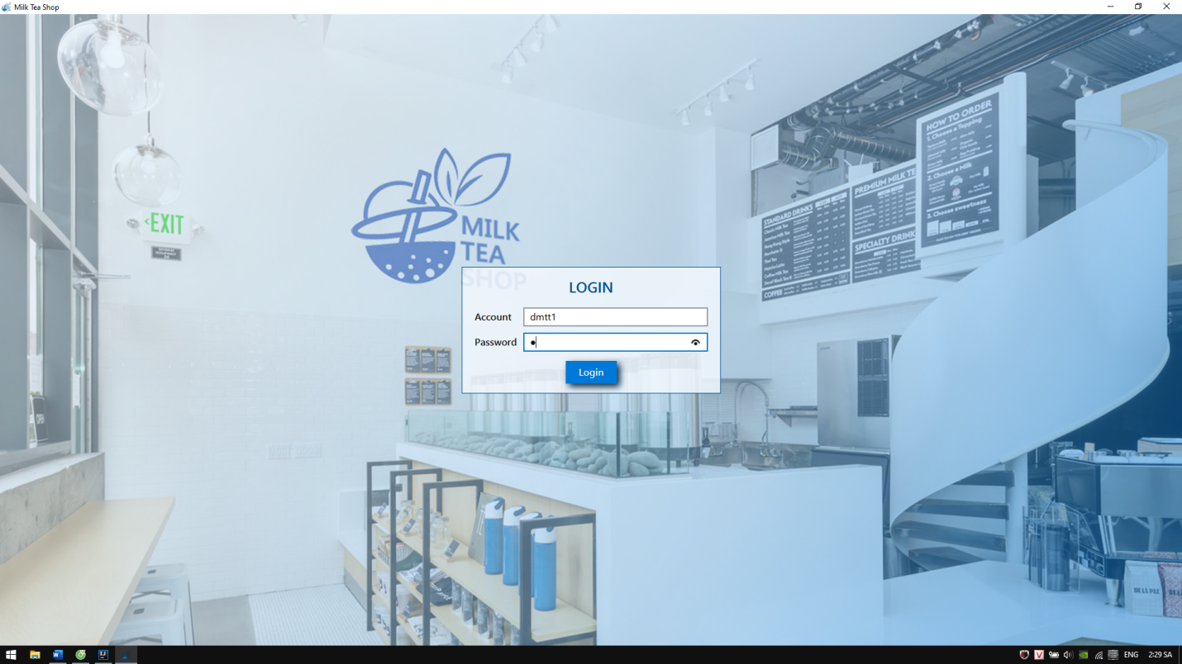

Figure 36: Login system

Then main manager form will appear. Click on function buttons for managing shop with income management, shop management, menu management and account management. At income management, manager can follow income movement in this month and last month. Beside that, manager can see the top customer and top food.

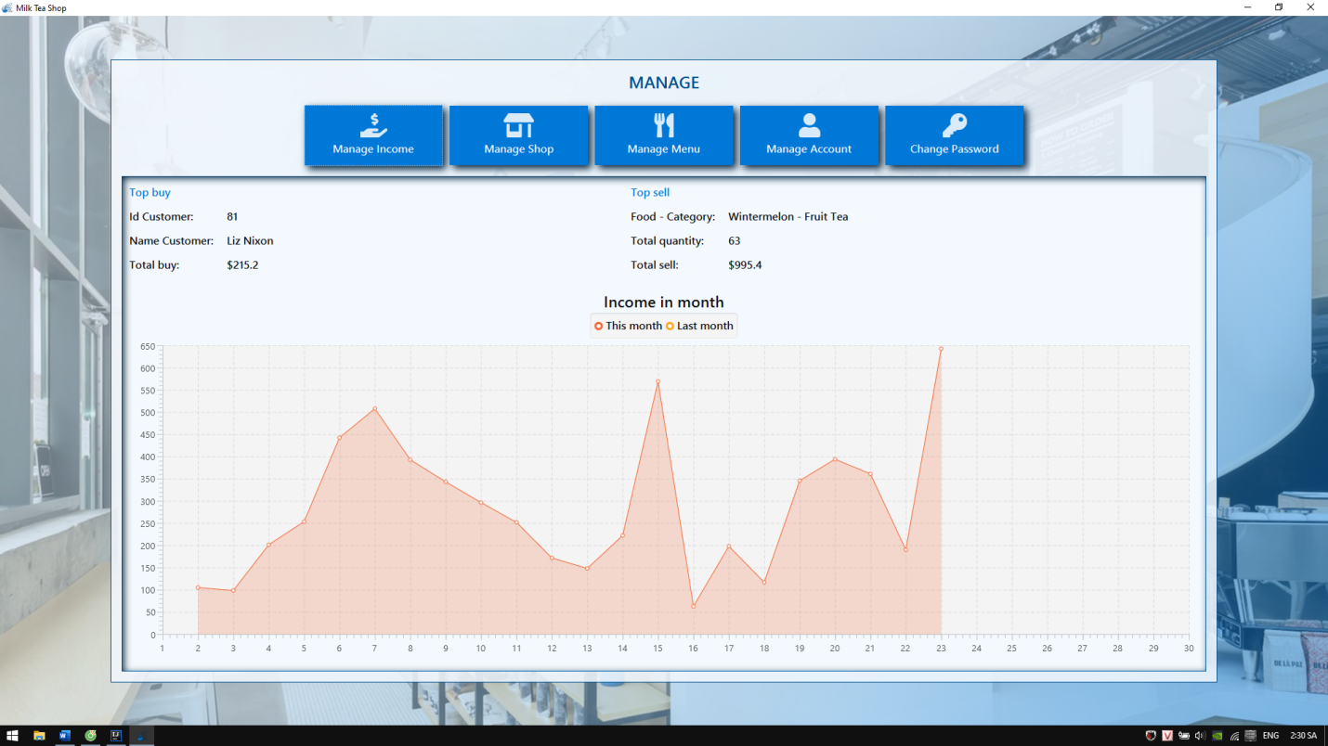

Figure 37: Main manager form

At position table management form, manager can insert or delete table by right click on table button. Beside that, manager can move tables by drag and drop table button.

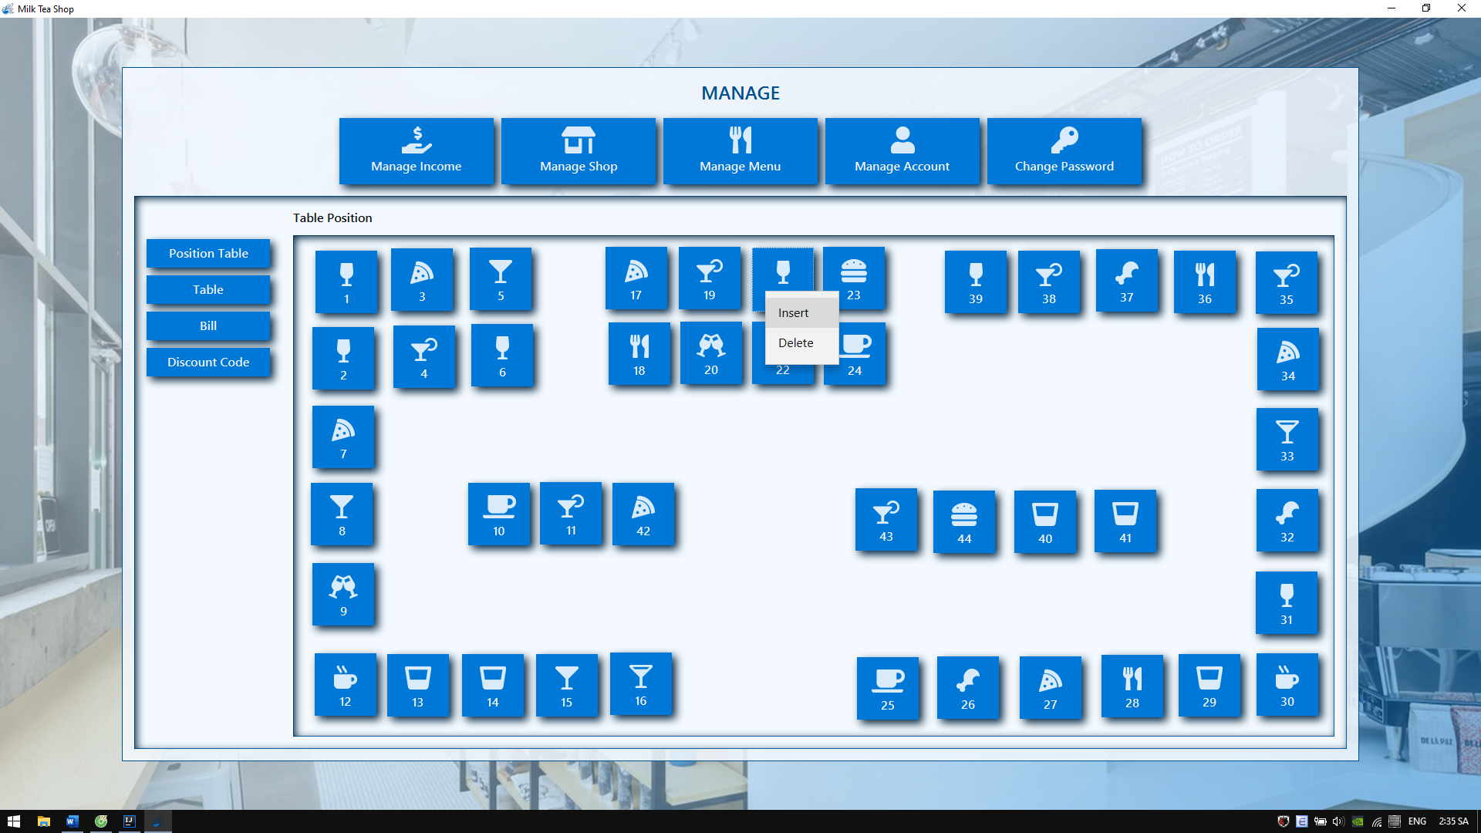

Figure 38 Position table management

At table list management form, manager also can insert or delete table. Beside that, manager can change status of table. The table which has been disabled won’t appear when customer choose table.

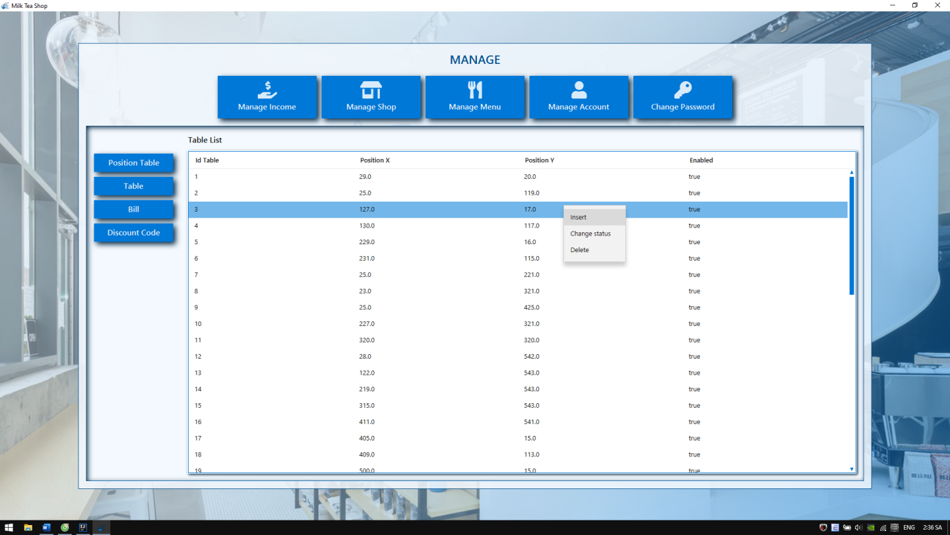

Figure 39: Table list management form

At bill list management form, manager can see bill list by choose the table and select datetime of bill. Beside that, manager can watch bill details, customer who ordered that bill or employee who received payment by right click on that bill.

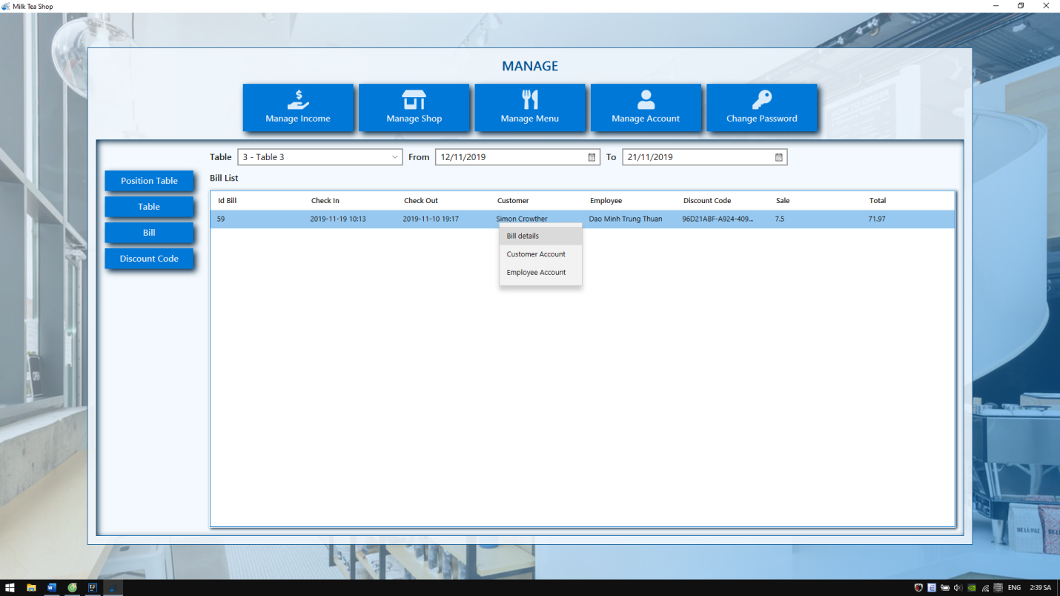

Figure 40: Bill list management form

At discount code management form, manager can insert, delete, change status code. The code which is given out will print in bill of customer.

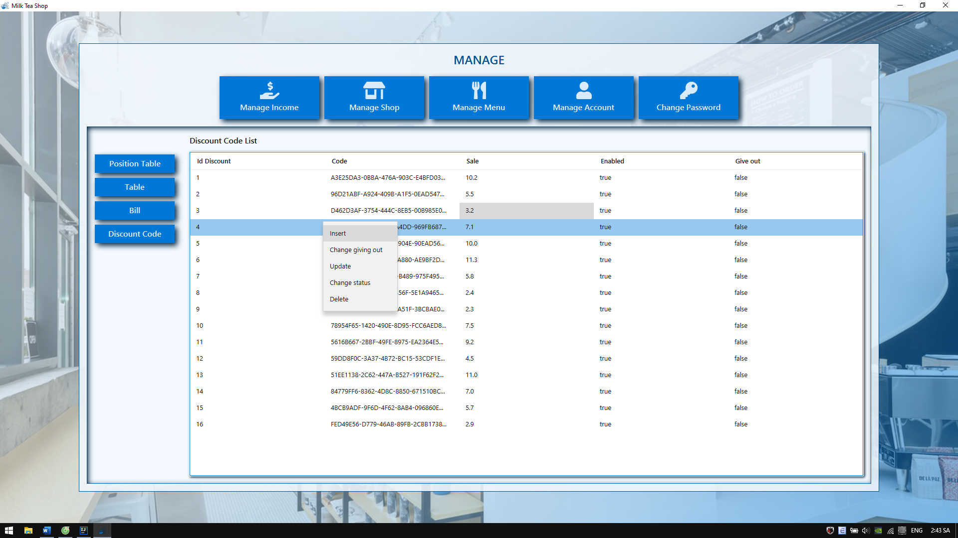

Figure 41: Discount code management form

At form menu management form, manager can insert, delete, update or change image food and category by right click on button.

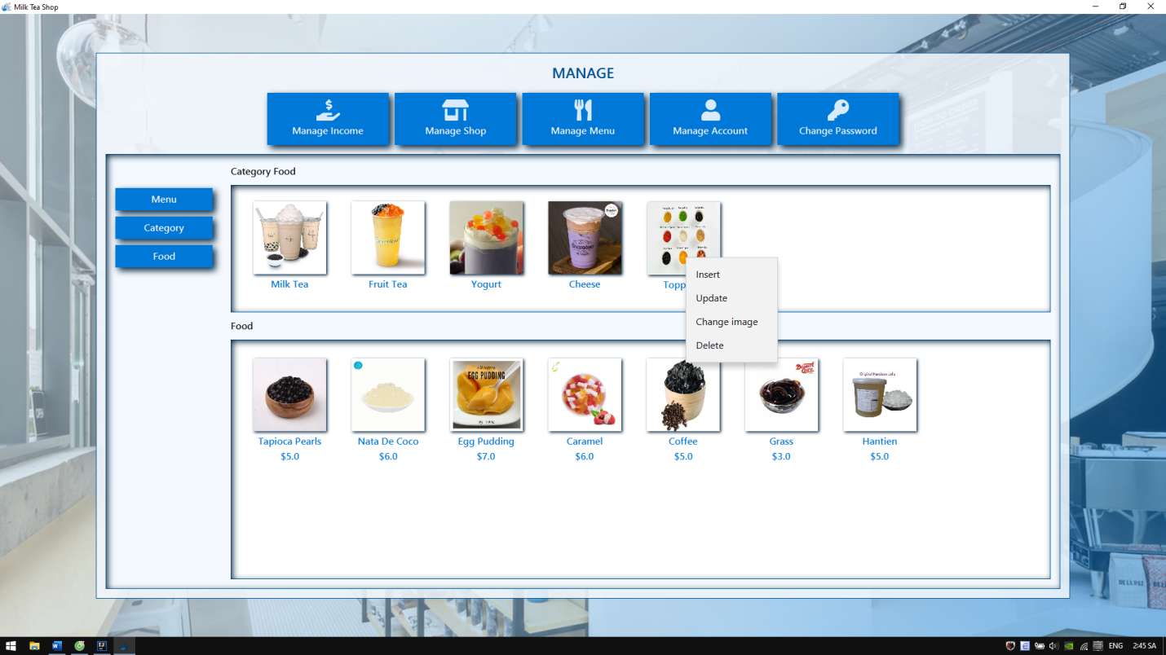

Figure 42: Menu management form

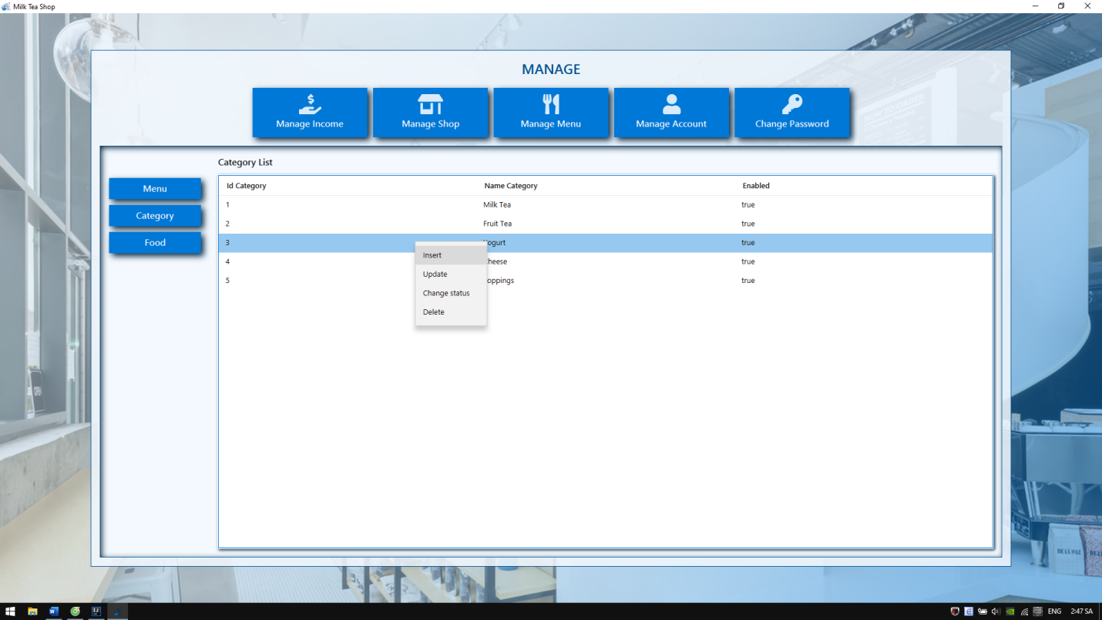

Figure 43: Category list management form

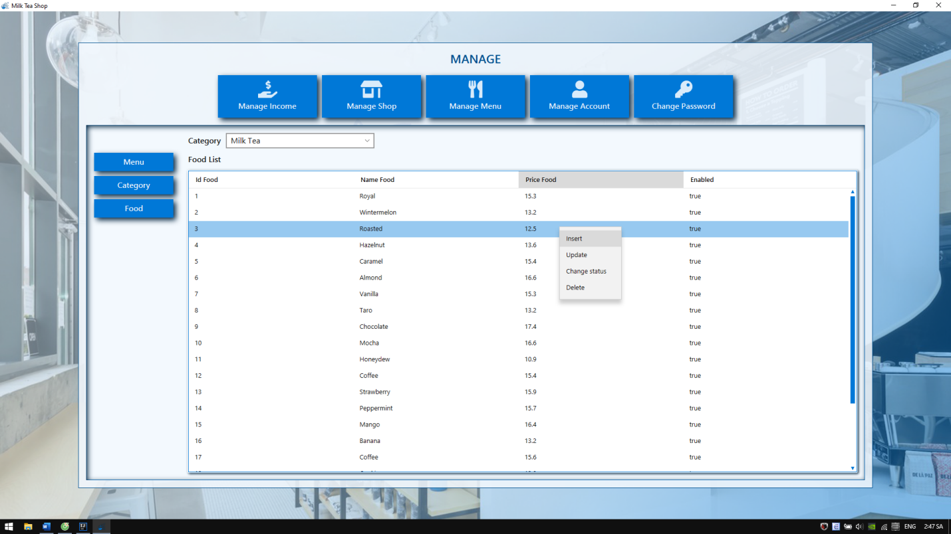

Figure 44: Food list category management form

At account management form, manager can insert, update, change status or delete account of customer, employee and manager.

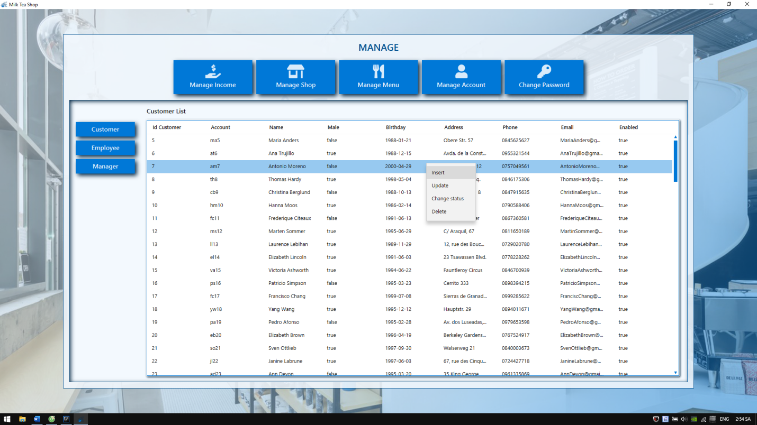

Figure 45: Account management form

Beside that, manager can change password by click on change password button

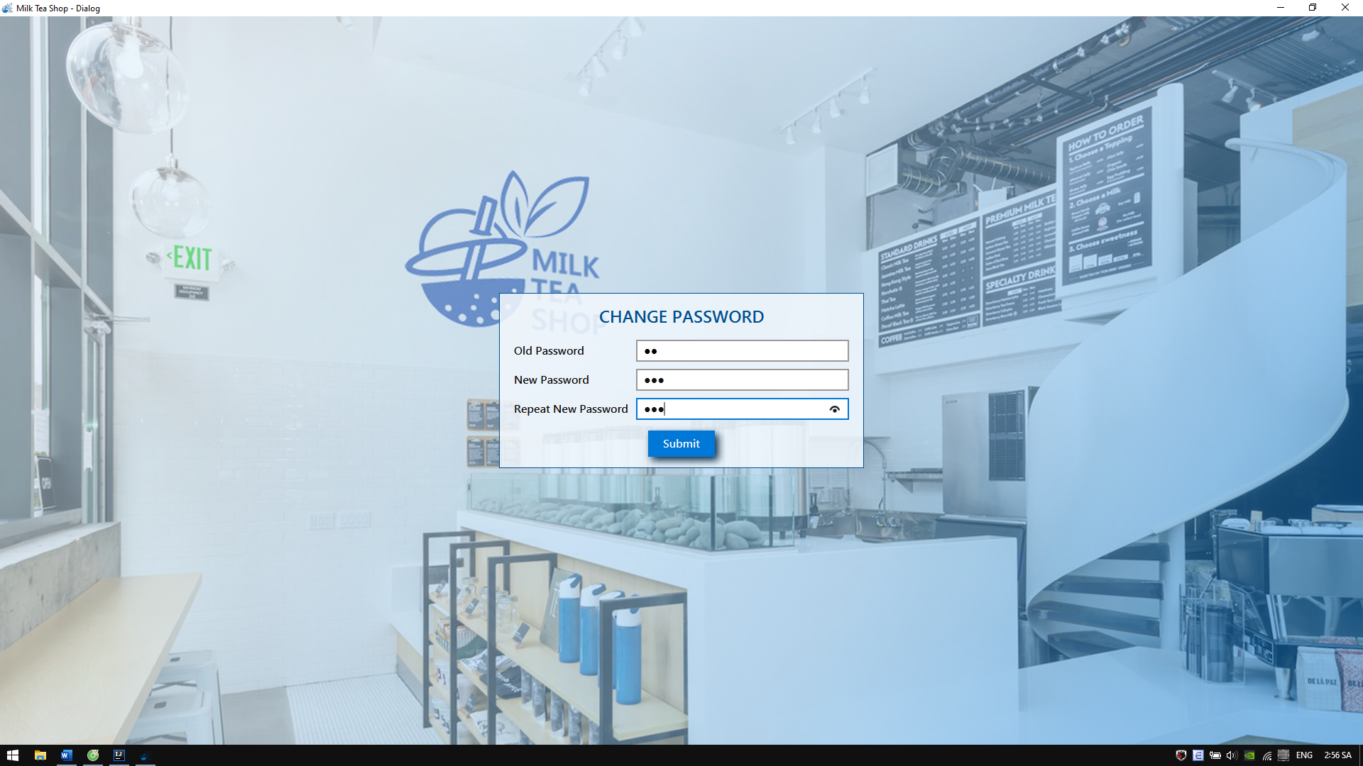

Figure 46: Change password form

When customer is ordering, employee can watch ordered bill. Employee can cancel this order by close manage order form. When customer finished ordering and give money to employee, employee click on pay bill button to finish.

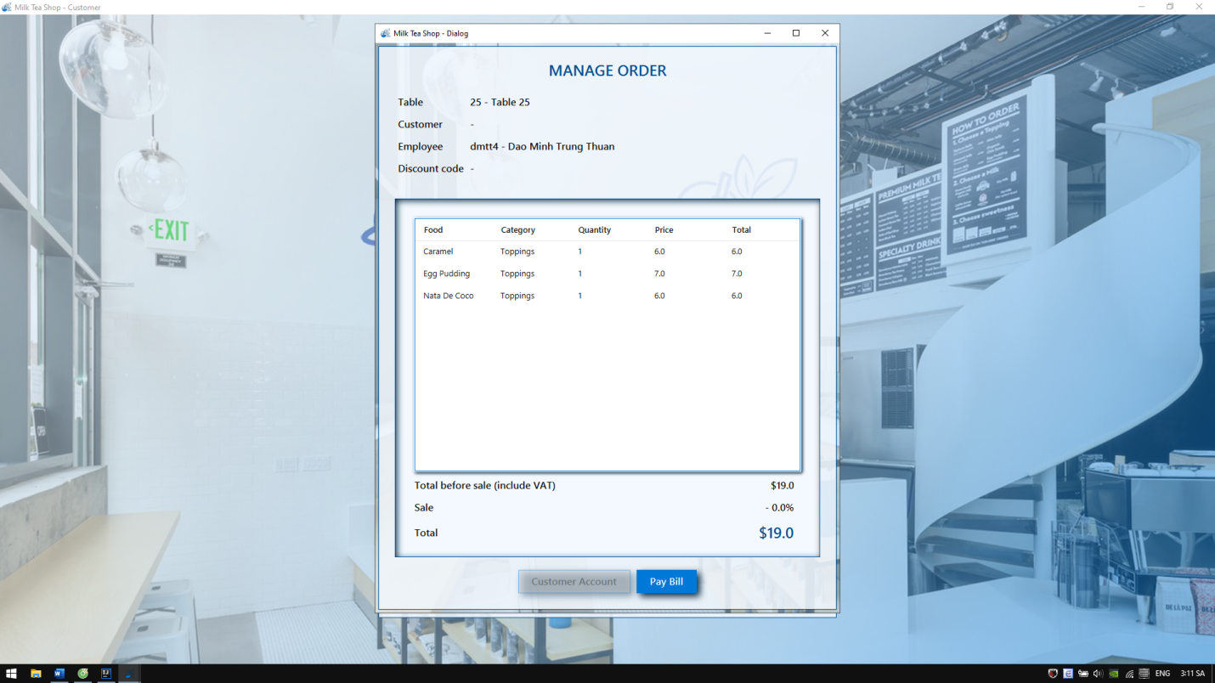

Figure 47: Manage order form

## For employee

Using test account to login system with account: “dmtt4” and password “1”. The main form for employee and welcome customer form will appear. Employee has same function as manager but employee cannot insert, update or delete anything, employee only can watch. Beside that, employee can change password own account. After login, please drag and drop welcome customer form to the secondary display screen and click on Open shop button to setup system for customer.

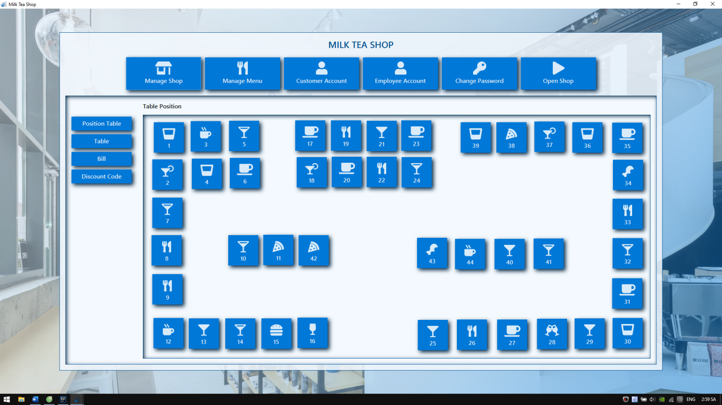

Figure 48 Main form for employee

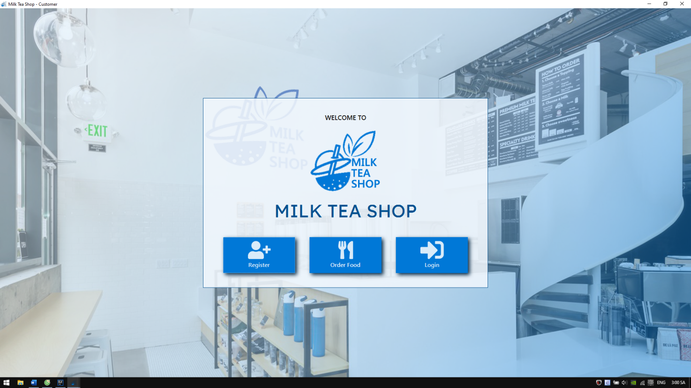

Figure 49: Welcome customer form

## For customer

Customer can register account or login by customer account at welcome form. After that, system will bring to Order food form. At that form, customer can choose category and food to order. Beside that, customer can enter discount code, change password own account or watch information account.

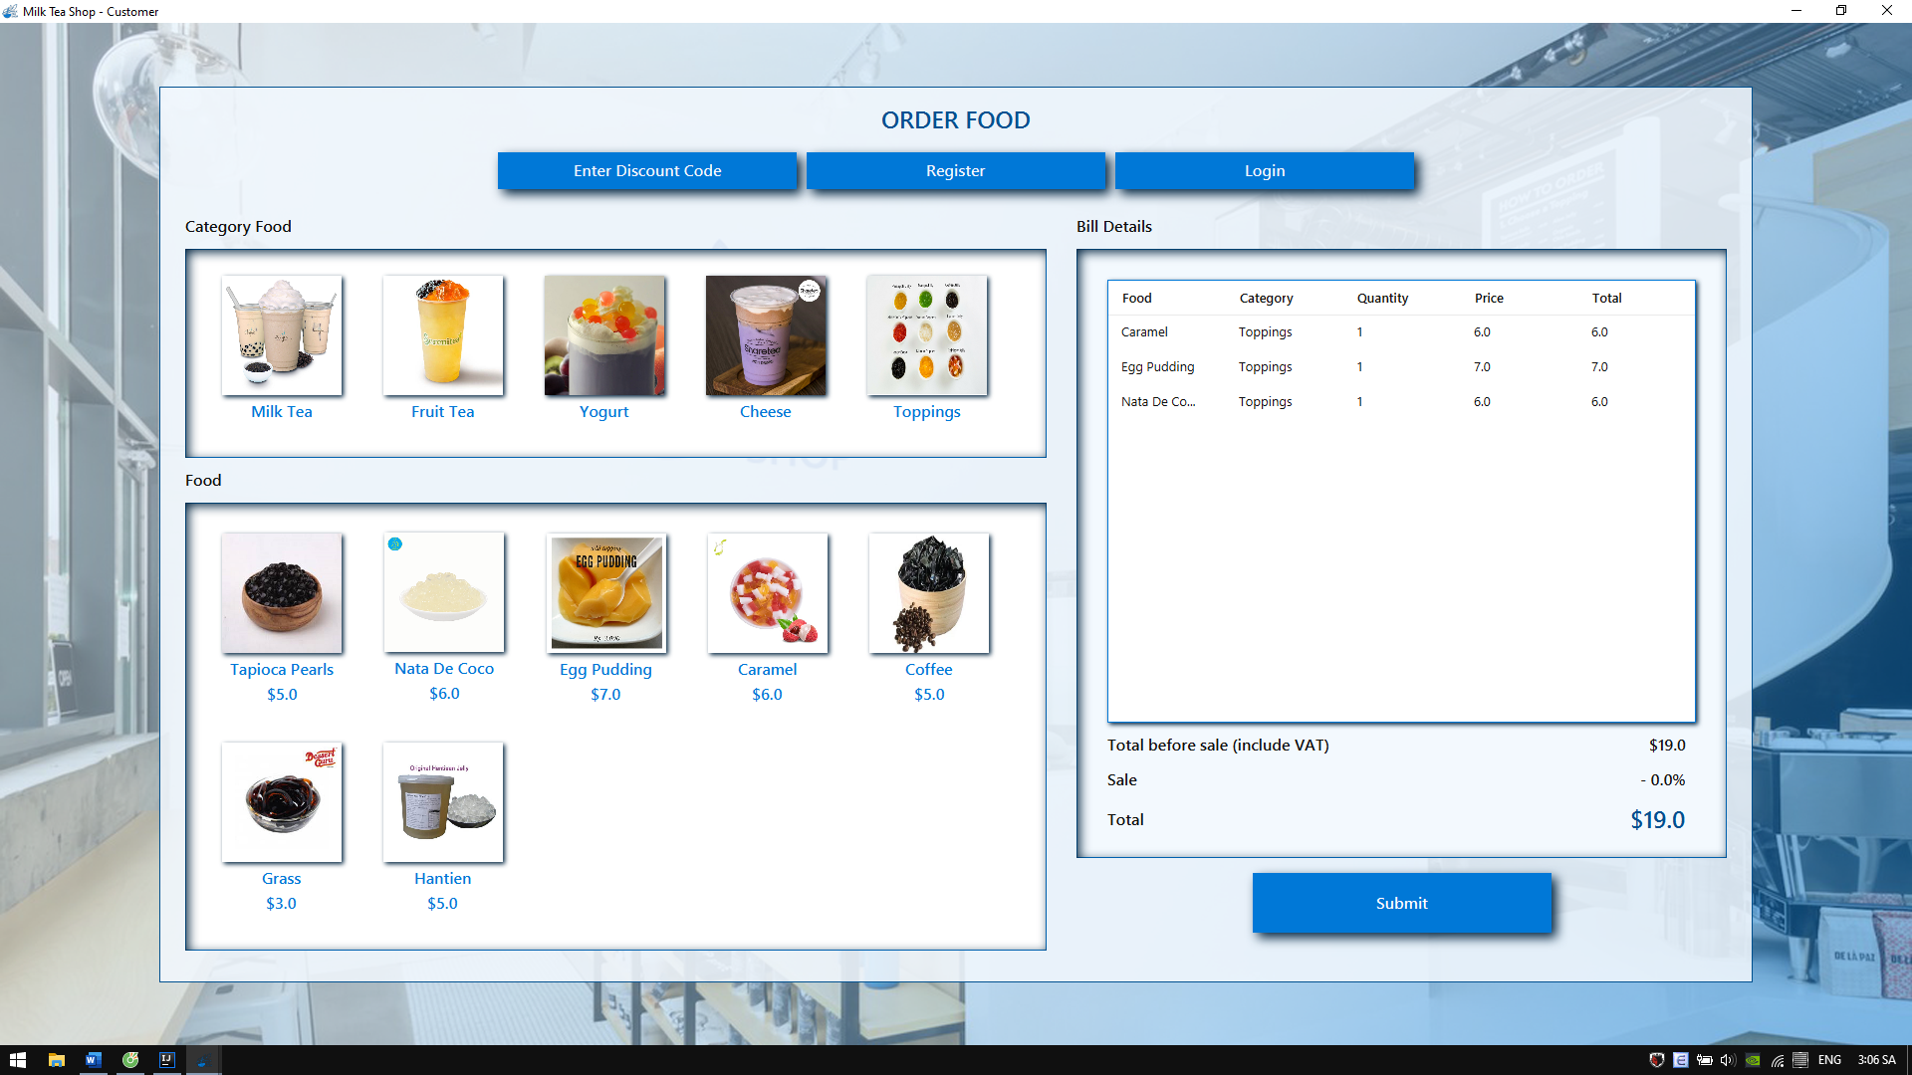

Figure 50: Order food form

When finishing ordering food, customer click on submit button to go to choose table form.

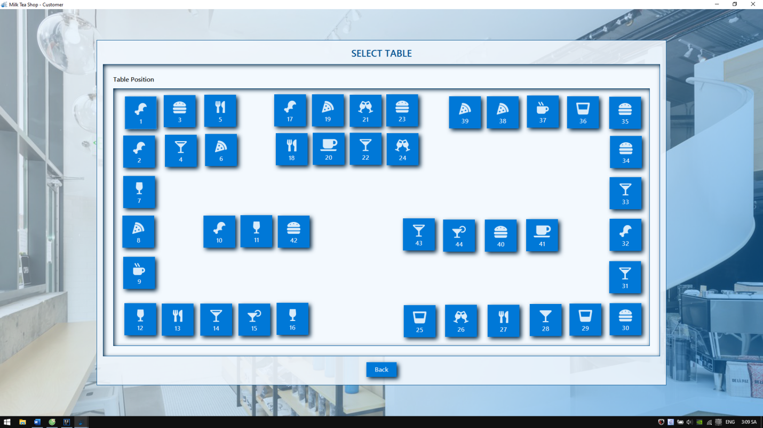

Figure 51: Choose table form

Customer choose table to pay bill then give money to employee for paying bill.

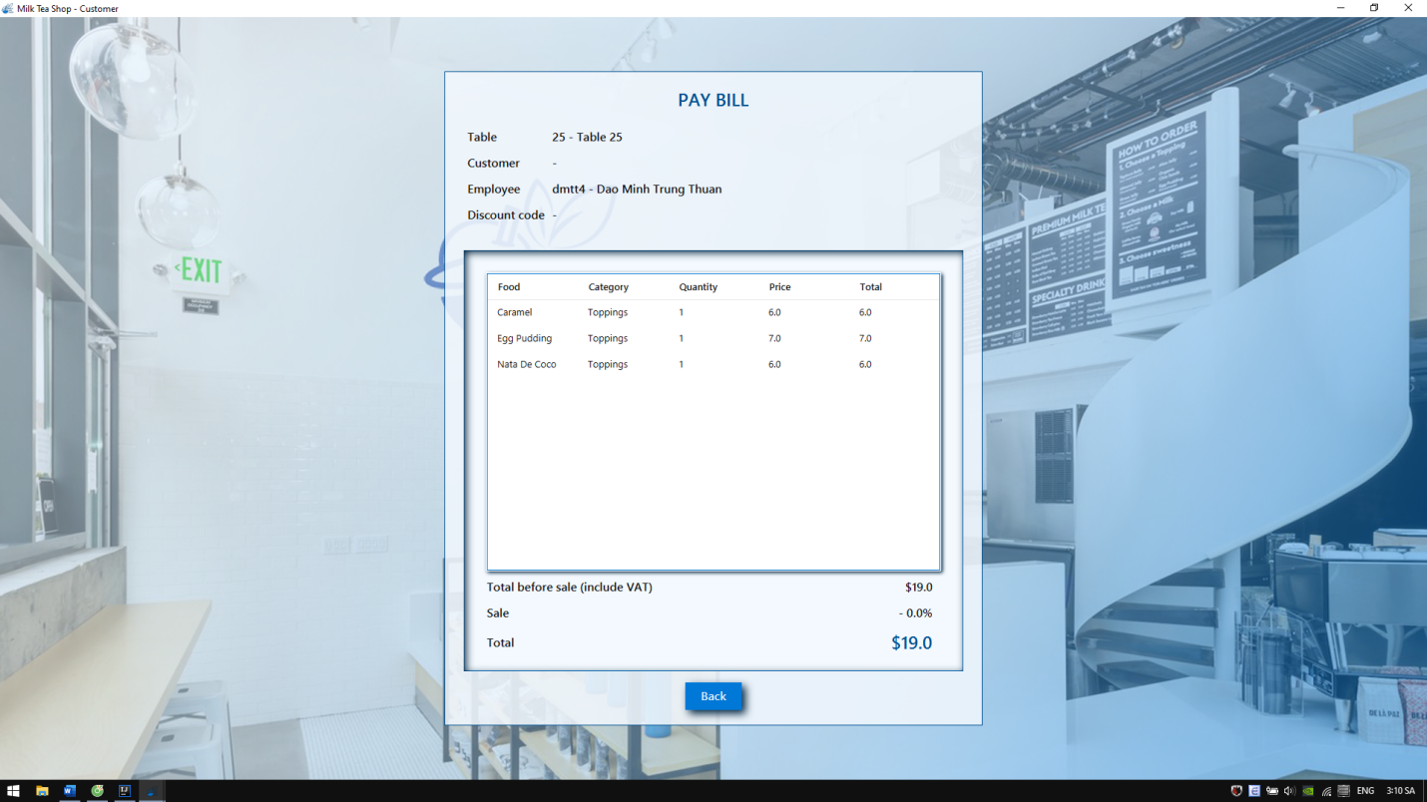

Figure 52: Pay bill form